Enterprise AI UX Transformation: Simulation Workbook

Scenario
You are the lead AI strategist for your selected company and industry, responsible for leveraging AI to drive meaningful business transformation. Executive leadership has tasked you with three distinct initiatives, each tied to a different AI-capability and corresponding innovation horizon.
For every initiative, you’ll partner with external consultants and internal teams. You’ll create one Experience Brief per initiative. Think of these briefs as the cross-functional handshake: documents that clarify vision, use cases, and business fit so every partner, inside and outside the company, starts with a unified understanding before solution development begins.

Collectively, the three briefs roll up into an AI Experience Portfolio Strategy, an integrated action plan that propels business modernization, sharpens the company’s competitive edge, responds to evolving customer demands, and positions the company for long-term success.

Note: An experience brief centers on the sweet spot where user needs, technology capabilities, and business outcomes overlap, unlike a product brief, which revolves around schedules and milestones. When covering technology, an Experience Brief highlights what the tech can do for users, not deep implementation details.

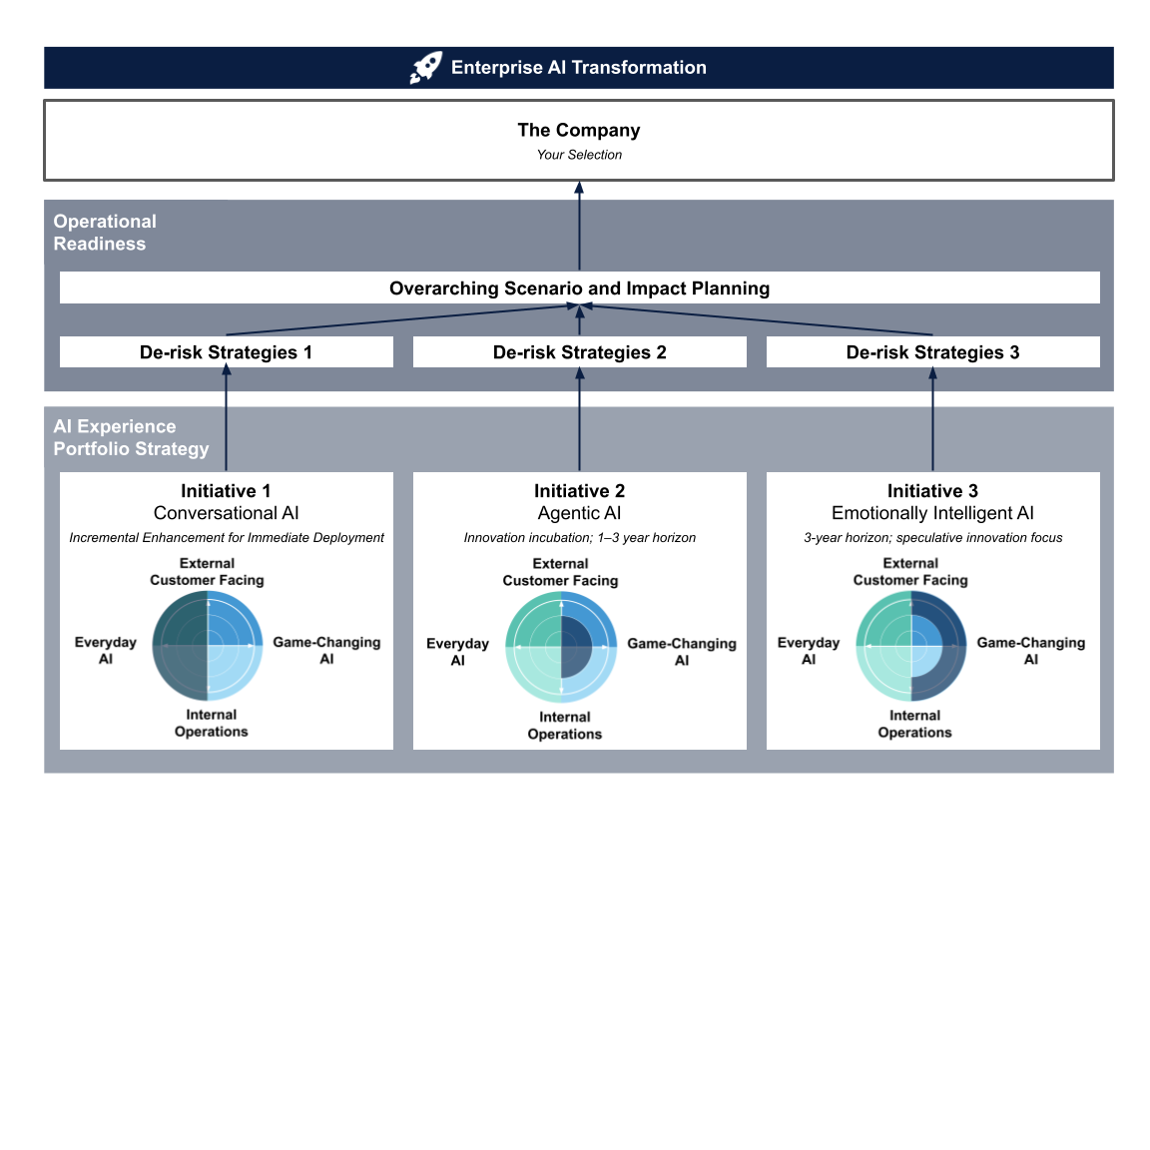

Ground Work: Select The Company
Before creating the experience brief, you will need to select a company. This step is crucial to the success of your final project journey. Choose a company with sufficient materials and a strong case that can run through the simulation across three types of AI experience design. Use the key considerations below and work through them one by one.

Not sure your selected company can carry the full simulation? Contact the professor via Canvas or office hours to review its viability.
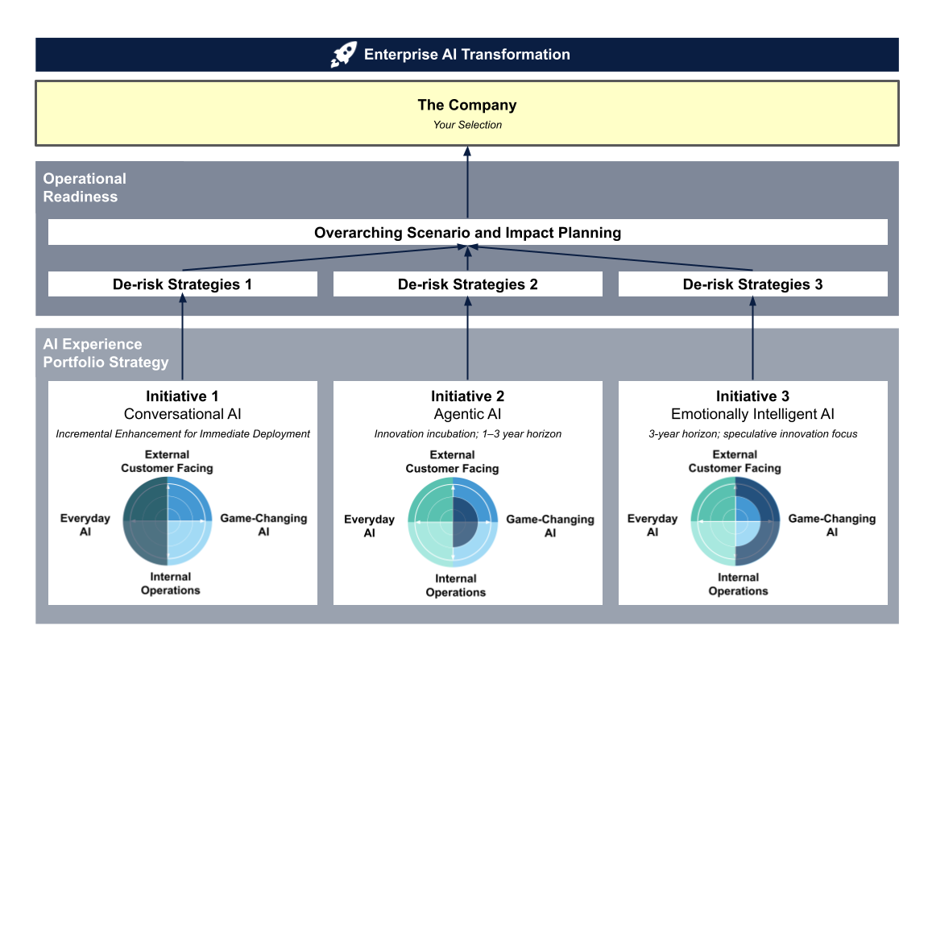
Reference:
- Module 2 Enterprise AI UX Transformation Playbook
- Module 3 The Skeleton of a Great AI Experience: Pillar 1 Real-World Needs

Step: Select a real company in an industry aligned with your interests or career goals
Consider:
1. Your interests or career goals
- Is there a company you’d genuinely like to work for, or consult with, in the future?
- Are there sectors where you’re especially curious about how AI is reshaping user experience?
- What type of organization (e.g. startup, nonprofit, Fortune 500) best reflects the kind of AI UX challenges you want to solve?

Note: You may choose organizations from the private enterprise sector, SMBs, startups, or nonprofits. Government cases are least recommended for this course’s simulation due to added constraints and limited publicly available information. If you have a specific government case in mind, contact the professor to discuss suitability.

2. Industry specifics
In Module 3, “Real Work Needs,” we look at various industries, their characteristics, challenges, and specific needs related to AI. From marketing, tourism, and advertising to retail, insurance, finance, law, supply chain, logistics, manufacturing, sports, education, the energy sector, and the public sector, each industry presents unique stakes and constraints that must be considered when designing effective AI solutions.
3. Available public insight
- Can you find sufficient public data about this company’s operations, products, customers, or its AI stance and strategy?
- Has the company already adopted AI technologies, or are they just beginning to explore them?

4. Simulation feasibility
- Can you use this company to sustain the simulation across all three initiatives successfully?
- Can you envision meaningful opportunities for this company to include Conversational AI, Agentic AI, and Emotionally Intelligent AI solutions in its portfolio?
- Do you anticipate any difficulty coming up with ideas for one or more of these AI initiatives later in the course?

Take a moment to capture your ideas and how you're thinking through this decision.

AI Experience Portfolio Strategy

Initiative 1: Conversational AI Experience
Focused on Incremental Enhancement for Immediate Deployment

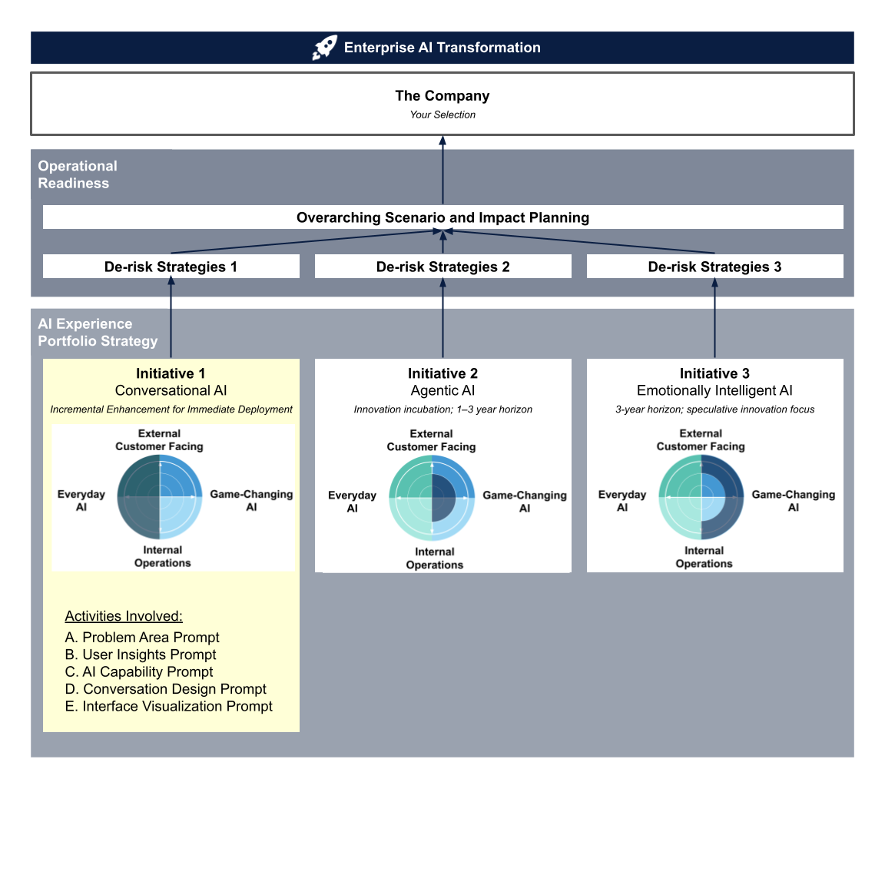

Introduction
Your first initiative is to design a conversational AI solution. This could be a chatbot, voice assistant, or multimodal experience.

This initiative is funded through an incremental enhancement approach (as introduced in Module 2), meaning you’re focused on improving an existing experience by identifying a specific problem area and using AI to elevate or streamline it.

Purpose
The following exercises are designed to help you critically evaluate each component that will formulate your Conversational AI Experience Brief.

A. Problem Area Prompt
In your selected company, which specific workflow, process, or user demand will your conversational AI enhance? Focus on the dark blue section in the graph below; it illustrates the incremental enhancement approach.
This section builds on the foundational insights you developed in Phase 1. Consider how your understanding of AI UX principles, user types, and industry-specific challenges can inform the decisions you make here.
Reference:
- Module 2 Enterprise AI UX Transformation Playbook: Move 1 Strategic Alignment, Move 2 Ambition Setting
- Module 3 The Skeleton of a Great AI Experience: Pillar 1 Real-World Needs
- Module 6 Designing Conversational AI: Start with Real-World Needs
Select one and explain the rationale for why this is an appropriate problem area for conversational AI within your company. Briefly describe the workflow involved in this context.
- Internal efficiencies (e.g. employee onboarding, IT support)
- Customer Support (e.g. long wait times, inconsistent support)
- Missed opportunity (e.g. unconverted leads, lack of 24/7 service)

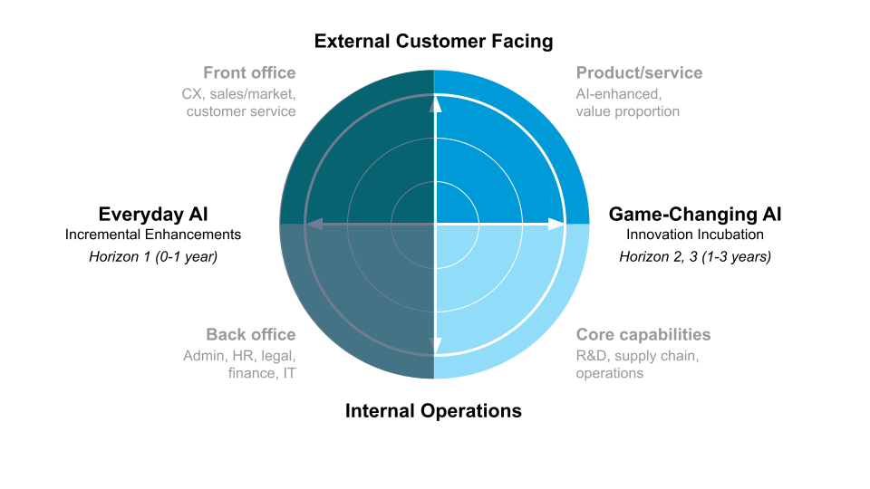

B. User Insights Prompt
Now that you’ve identified a key problem area, it’s time to understand who the users are within that context. Use this section to define your target users, their behaviors, and their expectations within the workflow you described.

Reference:
- Module 1 Who Are The Users?
- Module 1 Meet Your Users Where They Are: Shifting User Behaviors | Rising Expectations
- Module 2 Enterprise AI UX Transformation Playbook: Move 3 User Insights Frontloading
- Module 2 Trade-off: AI vs. Comfort Zone
- Module 3 The Synthetic Persona Tool: Bringing “Meet Your Users Where They Are” to Life

Step 1. Who are your users?
- Internal user (e.g. employee, support agent, technician, sales)
- External user (e.g. customer, partner, patient)
- Both

Step 2. User Insights
Use the space below to outline the typical behaviors, motivations, and pain points of this user in the selected problem area:

Behavior Patterns:
Do users carry over any behaviors from previous technological eras or systems when engaging with this workflow?

Expectations:
What new expectations—around speed, personalization, accuracy, or autonomy—have users formed due to the growing presence of AI in similar experiences?

AI Familiarity & Attitudes:
How comfortable or skeptical is this user group toward AI-driven experiences?

Step 3. Synthetic Persona
Based on your analysis, use AI to generate a synthetic persona that represents the user you’re designing for. If you’ve identified multiple user groups, generate one persona for each.

  Find a picture that represents your user in the workflow. It doesn’t need to be a happy, smiling image—the focus is on realistically conveying the user’s challenges.  Quote that represents their mindset:  “  “ | Persona Name:  Role / Background:  Goals (related to this problem area):  Frustrations / Barriers:  Tech Comfort / AI Familiarity:  - High familiarity and trust in AI  - Limited experience but open-minded  - Skeptical or cautious  - Other: _____________________________  Notes or observations:

Step 4. Confirm Strategic Alignment
Before moving forward, pause to confirm that this user opportunity aligns with your company’s broader strategic goals.

Is this Conversational AI solution designed to be…
- Touchpoint 1: Directly customer-facing
→ Customers interact with the conversational AI directly to complete tasks, ask questions, or receive support (e.g. a support chatbot on a website), while employees step in to assist when more complex questions arise that the AI cannot address.
- Touchpoint 2: Internally facing, with indirect customer benefit
→ Employees are the primary users of the conversational AI, using it to streamline internal workflows, find information, or respond faster—ultimately improving the customer experience through better service, speed, or consistency.
Why it matters: This decision shapes how you think about design, context, modality, and feedback loops. It also affects how you measure success—customer satisfaction vs. employee productivity or resolution times.
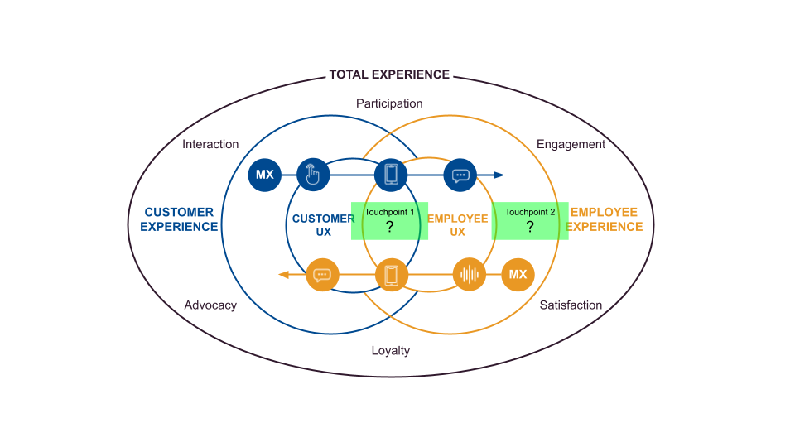
Your rationale:
How does addressing this need support the company’s strategic direction? Will this solution reinforce existing strengths or unlock new potential?

C. AI Capability Prompt
Now that you’ve analyzed your users and defined their needs, it’s time to scope the AI capabilities that can support the experience you’re designing.

Remember: This section is not about technical implementation details. In an experience brief, your focus is on what the AI can deliver for users—how it enhances interaction, reduces friction, or creates value—not how the model is trained or which cloud stack it runs on.

Constraint Reminder: This initiative is funded through an incremental enhancement approach, meaning your solution must be realistic for short-term deployment. Choose AI capabilities that build meaningfully on existing systems without requiring full-scale transformation.

Reference:
- Module 2 Trade-off: AI vs. Comfort Zone
- Module 3 The Skeleton of a Great AI Experience: Pillar 2 Technology
- Module 6 Designing Conversational AI: Mapping Use Cases to AI Capabilities

Step 1. Identify AI Capabilities that Support the Experience
Which capabilities will allow your conversational AI to support the selected workflow and user needs? Select those that apply:
- Natural Language Understanding (NLU)
- Generative AI
- Sentiment Analysis
- Retrieval-Augmented Generation (RAG)
- Predictive Assistance
- Computer Vision
- Text-to-Speech or Speech Recognition
- Other: _____________________________

Step 2. Justify Your Selection
Your rationale:
Why are these the right capabilities to support your users and use case? Briefly describe how this selection supports your users in the identified problem area for your company.

Step 3. Feasibility Check
Do these capabilities align with the incremental enhancement goal (i.e., near-term deployment, builds on existing systems)?
- Yes
- No (If not, revise your scope to better fit the funding and deployment constraints)

What trade-offs or simplifications will you make to keep this proposal viable?

D. Conversation Design Prompt
In this section, you’ll translate your selected problem area into a simple visual that shows how a user and the conversational AI interact to address the need. This is not about polished design. It’s about communicating the logic of the interaction clearly.

Reference:
- Module 5 Designing for Trust: Human Side | AI Side | Best Practices
- Module 6 Designing Conversational AI: The Bridge Between Tech and Users | 5 Conversational AI Design Principles
- Module 6 Designing Conversational AI: Choosing the Right Modality for Natural User Workflows

Step 1. Diagram the Experience Flow
Your goal is to sketch or outline a realistic interaction flow that shows how the user begins the experience, how the AI responds, and how the exchange resolves. You can use a labeled flowchart. Include:
- The user’s entry point (e.g. question, command, task)
- AI responses and branching logic
- How the flow handles success, errors, or escalation

Visual Workspace:



Step 2. Apply Conversational Design Principles
Complete the section below with 1–2 sentences per principle, explaining how your conversational AI design addresses each one.

Principle 1. Branding & Persona

Principle 2. Intent Recognition

Principle 3. Context Awareness

Principle 4. Effective Dialogue

Principle 5. Error Handling

Step 3. Choose the Right Modality
Once you’ve defined the user and envisioned how the AI will interact with them, it’s time to determine the best modality for delivering that dialogue. Modality refers to the way users will interact with your conversational AI, whether through text, voice, visuals, or a combination of these.

Your goal is to choose the modality that best supports the user’s environment, task, physical context, and trust level—while staying aligned with the company’s ability to deploy it as an incremental enhancement.

Choose the primary interface for your conversational AI:
- Text-based chatbot
- Voice assistant
- Multimodal experience (e.g. voice + visuals, text + image support)
- Other: _____________________________

Evaluate modality fit for the user context. Briefly describe the factors that influenced your decision.

User environment (e.g. quiet, private, public)

Motion or activity level (e.g. hands-free, on-the-go)

Proximity to device or screen

Level of trust and comfort with modality

Type of task (e.g. quick inquiry vs. complex transaction)

Briefly explain why this modality—or combination of modalities—is the best fit for your selected problem, user, and workflow. How have you leveraged the strengths of the selected modalities and mitigated their weaknesses?

Your Rationale:

E. Interface Visualization Prompt
Now that you’ve outlined the design principles behind your conversational AI solution, it’s time to bring your ideas to life by visualizing one sample interaction: one where the AI successfully helps the user complete their task.

You are not expected to produce coded prototypes. Focus on demonstrating the logic and flow of the interaction. Use labeled dialogue bubbles to show how the system responds to user input, how it maintains context, and how it ensures a smooth experience.

Reference:
- Module 5 Designing for Trust: Human Side | AI Side | Best Practices
- Module 6 Designing Conversational AI: The Bridge Between Tech and Users
- Module 6 Designing Conversational AI: Choosing the Right Modality for Natural User Workflows
- Module 6 Conversational AI in Action
- AI and Digital Tools for Prototyping in the syllabus

Step 1. Low-fidelity Sketches
Visual Workspace:
Script a realistic interaction in which the AI successfully helps the user complete a task.



Step 2. High-fidelity Prototype: Selected Set of Screens
Now, use your selected AI-assisted prototyping tool to turn your low-fidelity sketches into a high-fidelity screen/interface for the conversational AI experience you designed. Create at least one prototype with a set of selected screens that clearly visualizes your concept. Focus on the key UI elements and user interactions to bring your idea to life. The selected prototype screens should represent the key essence of your initiative.

Initiative 2: Agentic AI Experience
Focused on Innovation Incubation for a 1–3 year horizon

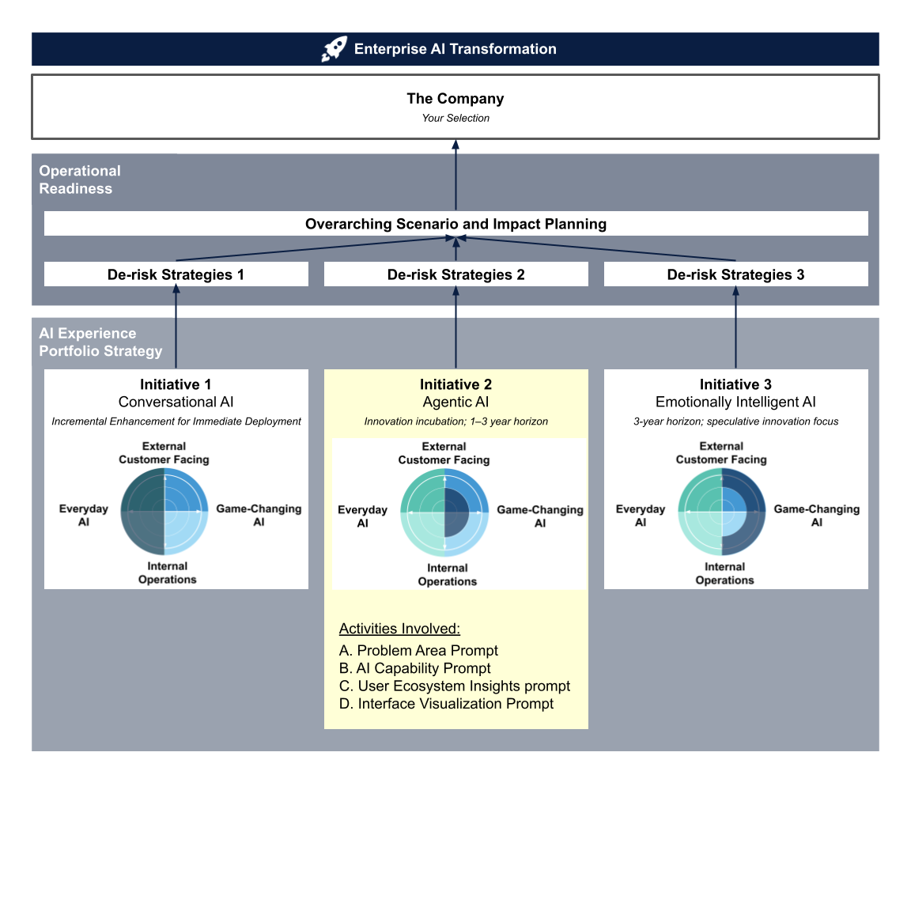

Introduction
An enterprise’s technological transformation is never one-dimensional. In this initiative, you will shift focus from Conversational AI to Agentic AI capabilities. That means you’ll identify a new problem, one whose solution is uniquely suited to AI agents and their strengths in autonomous action and support at scale.

You’ll design a distinct AI solution for the same company and industry you chose earlier in the workbook. Unlike the prior Conversational AI effort funded as an incremental enhancement, this initiative is backed by innovation-incubation funds, encouraging bold, near-term applications of Agentic AI within a 1–3-year horizon.

Purpose
This exercise lets you practice a different innovation approach, showing how AI-UX thinking shifts when you move from incremental enhancements to innovation incubation. You can compare approaches side by side and know when to use each.

By the end, you’ll produce an Agentic AI Experience Brief, the second strategic pillar in your simulated AI-UX transformation narrative.

With Initiative 1 already complete and Initiative 2 now underway, you will have tackled two distinct problems in sequence, demonstrating how to match the right AI capability to the right challenge and maximize enterprise growth, innovation, and user-centered outcomes.

A. Problem Area Prompt
Agentic AI represents a newer, less-mature capability than Conversational AI. Whenever you’re dealing with something this fresh, anchor your exploration in a side-by-side assessment: agentic AI’s early-stage strengths and gaps versus the problems your company and its users actually face. Select use cases where the benefits clearly outweigh the unknowns.

Reference:
- Module 2 Enterprise AI UX Transformation Playbook: Move 1 Strategic Alignment, Move 2 Ambition Setting
- Module 3 The Skeleton of a Great AI Experience: Pillar 1 Real-World Needs | Pillar 2 Technology
- Module 7 Designing Agentic AI Experiences: Probing Capability Frontiers
- Module 7 Designing Agentic AI Experiences: Early Learnings in Addressing Real-World Needs

Step 1. Initial Capability Assessment
Focus on the capabilities highlighted in Module 7: autonomy, optimal action selection toward a designated goal, adaptability, personalization, and scalability.

Strengths (Where the Agentic AI excels) | Gaps / Unknowns (Current limitations, risks)

Step 2. Business/User Problem Mapping
Use the thinking prompts below to brainstorm use cases where Agentic AI could deliver the most value. It could be one of the following cases:
- Business‑only focus: Address an internal efficiency gap (cost, speed, operational processes) that an AI agent could tackle.
- Customer‑only focus: Solve a pressing customer pain point or meet a rising demand that an AI agent could satisfy.
- Dual focus: Target a scenario where fixing the business issue also improves the customer experience (or vice versa).

Thinking prompts:
- Is this currently a problem of scale?
- Do we have the data to make it work?
- What are the main benefits?
- What does a mistake look like?
- How big are the risks?

 | Agentic AI Solution Idea |  | Proposed Value
Business-only Focus | 1.
 | 2.
 | 3.
 | 4.
 | 5.
Customer-only Focus | 1.
 | 2.
 | 3.
 | 4.
 | 5.
Dual Focus | 1.
 | 2.
 | 3.
 | 4.
 | 5.

Step 3. Alignment & Use Case Selection
Reflection:
What is your final use‑case selection? Describe it clearly and explain why Agentic AI is the best fit. Then note how the idea aligns with company strategy, outline expected impact, and capture key unknowns/risks.
- Internal efficiencies
- Customer-facing Support
- Missed opportunity
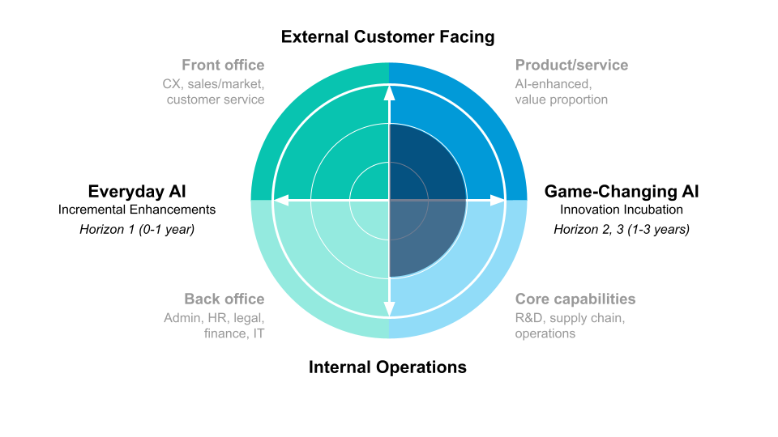

B. AI Capability Prompt
So you’ve identified the problem space where Agentic AI can help. Now let’s look at the high-level orchestration of the Agentic AI solution you envision.

You might wonder why, in this initiative, we moved the AI Capability prompt before the User Insights prompt. The reason is that each autonomous AI agent in your multi-agent team functions as a “user” of the system: navigating interfaces, making decisions, and interacting with other agents. Together, these AI agent users with human users form a unified user ecosystem you must consider.

Reminder: This initiative is funded through an innovation-incubation approach for a 1-3-year innovation horizon. Among all the different types of AI agents you learned about in Module 7, a multi-agent solution is the most appropriate orchestration selection, rather than a single agent.

Note: This section is not about technical implementation details. In an experience brief, your focus is on what the AI can deliver for users: how it enhances interaction, reduces friction, or creates value. We won’t have you drill down to the memory or detailed multi-agent framework in this exercise.

Reference:
- Module 2 Trade-off: AI vs. Comfort Zone
- Module 3 The Skeleton of a Great AI Experience: Pillar 2 Technology
- Module 7 Designing Agentic AI Experiences: Probing Capability Frontiers

Step 1. Define Multi-Agent Team Structure
Which capabilities will allow your conversational AI to support the selected workflow and user needs? Select those that apply:

Visual Workspace:
Use the following prompts and sketch in the visual workspace to determine which multi-agent team structure best fits the problem space/workflow you identified.

Thinking Prompts & Example Use Cases by Structure:
- Sequential: Does your workflow break down into a clear series of steps that must happen in order (like an assembly line), where each agent’s output feeds the next step’s input?
  - Example use case: In an internal employee onboarding workflow - An automated HR system onboards a new hire step by step. A “HR agent” first collects all personal details, then passes them to an “IT setup agent” that creates accounts and credentials, which triggers a “Training agent” to schedule orientations. Each agent’s task completion kicks off the next, reflecting an assembly-line process that guarantees nothing is skipped.
- Hierarchical: Do you need an “AI team lead” agent to delegate tasks to specialized sub-agents and coordinate their work toward a goal?
  - Example use case: In a customer-facing Customer Support Orchestrator – A smart support chatbot acts as a manager agent that triages a customer’s query and dispatches specialist agents (billing, technical support, etc.) to handle parts of it. The manager agent then compiles the sub-agents’ findings into a single answer. This hierarchical setup lets a lead agent orchestrate expert helpers, ensuring the customer gets a comprehensive solution overseen by one coordinator.
- Parallel: Can parts of the task be worked on simultaneously by different agents without waiting for one another, to speed up the outcome?
  - Example use case: In an internal Concurrent Data Analyzer – An enterprise dashboard assistant runs several agents in parallel to prepare a report for an employee. Upon request, separate agents simultaneously fetch data from sales, marketing, and finance systems and analyze their respective datasets. The results are then combined into one comprehensive report. This parallel approach means the employee gets insights much sooner than if each data source were processed one-by-one.
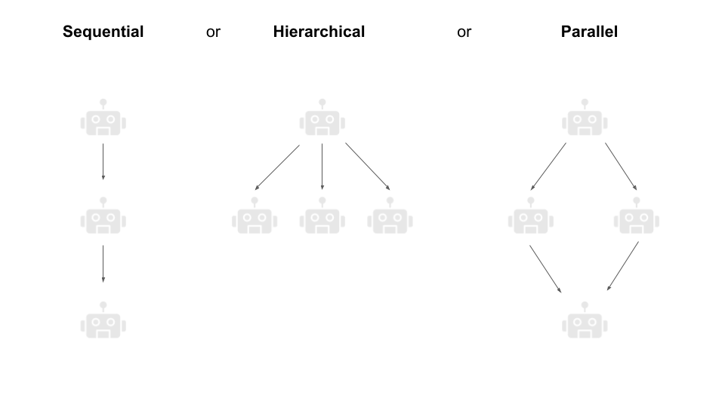

Step 2. Specify Agent Roles & Capabilities
In the space below, draw the defined team structure, then specify each agent’s role and required skills (as demonstrated by AI capabilities). Give each agent a name to make persona creation easier later.

Note: Ensure each agent’s role is distinct, and assign only major tasks to agents—don’t break down every minor step.

For example:
Agent Name | Role / Function | Skills / Key Capabilities
Planner Agent | Decomposes user request into subtasks | Planning logic; high-level goal reasoning
Research Agent | Gathers external or internal knowledge/data | Web search; data retrieval; summarization
Execution Agent | Carries out tasks (e.g. database queries, API calls) | Task execution; API integration

VIsual Workspace:
Agent Name | Role / Function | Skills / Key Capabilities

Step 3. Map Tools, Systems & Data Sources
Continue building from where you left off. Identify which tools, systems, or data each agent needs.

For example:
Agent Name | Tools / Systems Needed | Data Sources Required
Planner Agent | Project management tool | Company strategy docs; knowledge base
Research Agent | Web and internal document repository search | Public web; internal knowledge repository
Execution Agent | ERP, CRM | Transaction database

VIsual Workspace:
Agent Name | Tools / Systems Needed | Data Sources Required

Step 4. Describe Agent Interactions & Workflow
Lastly, combine your multi-agent team structure, each agent’s roles and skills, and their tools, then diagram the interaction flow. Label each arrow with what is being passed and ensure the diagram accurately reflects your chosen structure.

Use this step to verify that your system flows logically, with each agent interacting exactly as planned. Fill in the diagram and description using your specific agents, roles, and tools.

C. User Ecosystem Insights Prompt
Now that you’ve identified AI agents in your workflow (from Section B), it’s time to include them in your user ecosystem alongside human users. In this section, you will broaden your understanding of who (or what) your “users” are, gather insights about their needs, create personas to put those insights into context, and ensure the entire human–AI ecosystem aligns with strategic goals.

Reference:
- Module 1 Who Are The Users?
- Module 1 Meet Your Users Where They Are: Shifting User Behaviors | Rising Expectations
- Module 2 Enterprise AI UX Transformation Playbook: Move 3 User Insights Frontloading
- Module 2 Trade-off: AI vs. Comfort Zone
- Module 3 "New Team Member" in the AI era
- Module 3 The Synthetic Persona Tool: Bringing “Meet Your Users Where They Are” to Life
- Module 4 Decision Assessment: Allocating Human and AI Agency
- Module 4 Human-Al Collaboration: Designing the Relationship
- Module 7 Designing Agentic AI Experiences: The Bridge Between Tech and Users

Step 1. Who are your users?
1.1 List all participants in your workflow—both human users and AI agents. For each participant, note their role and what they need to achieve.

Example (Onboarding Workflow):
- New Hire (Human): Provides personal details and completes onboarding tasks.
- HR Agent (AI): Collects new hire’s personal details, ensuring completeness before passing data on.
- IT Setup Agent (AI): Creates company accounts and credentials using the data from HR Agent.
- Training Agent (AI): Schedules orientation sessions after accounts are ready.

Visual Workspace:
“User”/Participant | Role and Goal to Accomplish

1.2 Sketch your ecosystem: reference Gartner’s Total Experience graph below to draw where each participant sits and examine their interactions and touchpoints with one another.



Visual Workspace:

Step 2. User Insights
With your full cast of users (humans + agents) identified, the next step is to gather insights:
- For human users, think about their goals, expectations, concerns, and any challenges they might face interacting with the system (especially where AI is involved). What does a successful experience look like for them? What might confuse or frustrate them?
- For AI agents, since they aren’t people with feelings, “insights” means understanding the functional requirements and constraints of each agent. What input does the agent need, and what output does it produce? Where could errors occur?

Note: Also consider how the agent’s performance impacts the humans – for example, if an AI agent is slow or makes a mistake, how would that affect the human user’s experience?

By examining both perspectives, you get a holistic view of the ecosystem’s dynamics. It can be helpful to imagine the process from each participant’s point of view, even the non-human ones, to ensure the workflow is smooth for everyone.

Human Users
Use the space below to outline the typical behaviors, motivations, and pain points of this human user in the selected problem area:

Behavior Patterns:
Do human users carry over any behaviors from previous technological eras or systems when engaging with this workflow?

Expectations:
What new expectations, around speed, personalization, accuracy, or autonomy, have human users formed due to the growing presence of AI in similar experiences?

AI Familiarity & Attitudes:
How comfortable or skeptical is this user group toward autonomous multi-agent experiences?

AI Agent “Users”
Review what you’ve accomplished in Section B. Use the space below to produce insights for each AI agent, focusing on outlining their functional requirements and constraints.

Functional Requirements:
- What input data does each agent require to operate correctly? What outputs must it produce, and in what format?
- What triggers the agent’s actions (e.g. a completed task by another agent, a user event)?
- What tools, or internal systems must the agent be able to access?

Behavior Patterns & Processing Flow:
- Does the agent operate continuously (e.g. monitoring queues) or only when activated?
- How does the agent coordinate with other agents (e.g. send/receive messages, update shared data)?

Performance Constraints & Error Modes:
- Where could the agent fail or produce errors? (e.g. missing data, API timeouts, model mispredictions)
- What fallback or retry logic should be in place?
- What dependencies could become bottlenecks?

Interaction Dependencies & Collaboration:
- Which agents depend on outputs from other agents, and how do they communicate?
- Are there any concurrency or sequencing concerns? (e.g. two agents writing to the same resource)
- What coordination mechanism ensures consistency? (e.g. locks, transactional writes, orchestrator logic)
- What human-in-the-loop (HITL) checkpoints exist?

Reflection & Synthesis
After completing the exercises above, reflect on these questions:
- How well do your AI agents’ requirements and behaviors align with human user needs?
- Where are the system’s biggest risks (e.g. single-agent failure, cascading errors)?
- What additional guardrails or adjustments are needed to improve reliability and user trust?

Step 3. Synthetic Persona
Now that you have a sense of who your users are and what they need, you can create synthetic personas to make those insights relatable.

For different human users, create a persona for each type. For AI-agent “users,” create one persona for the main agent that interacts with humans at the front end. In the AI-agent persona, consider “Frustrations” as situations where the agent doesn’t receive clear inputs or responses and can’t complete its task.

Human Users

  Find a picture that represents your user in the workflow. It doesn’t need to be a happy, smiling image. The focus is on realistically conveying the user’s challenges.  Quote that represents their mindset:  “  “ | Persona Name:  Role / Background:  Goals (related to this problem area):  Frustrations / Barriers:  Tech Comfort & Familiarity with Autonomous Multi-Agent AI:  - High familiarity and trust in AI  - Limited experience but open-minded  - Skeptical or cautious  - Other: _____________________________  Notes or observations:

AI Agent “User”

  Core operating principle that represents the AI agent’s designated system behavior.  It defines the unchanging policy guiding the agent’s internal decisions and behavior.  Example: Validate all mandatory new-hire fields for completeness and accuracy before emitting a ‘profile-complete’ event to trigger downstream processes.  “  “ | AI Agent Name / Function:  The AI agent’s identifier and primary function.  Example: HR Agent - Collects and validates new-hire personal details.  Assigned Role / Workflow Position:  The AI agent’s assigned role and where it fits in the workflow or user journey.  Example: Role: First point of contact to gather new-hire data. Workflow position: Sits at the start of the onboarding pipeline—receives form inputs from the New Hire, validates them, then triggers the IT Setup Agent.  Input Requirements  Key input signals or triggers required for the AI agent to act.  Example: Complete form submission from New Hire (e.g. name, address, SSN, tax info).  Output / Response Behaviors  Key outputs, actions, or response patterns the main AI agent provides to human users and to subsequent AI agents.  Example: Provides a confirmation message to the New Hire: “All your details are recorded; next, your IT accounts will be created.”  Processing Constraints / Known Limitations  System constraints, task scope boundaries, or other known limitations of the AI agent's capabilities.  Example: Cannot proceed until all mandatory data fields are filled  Example Scenarios Where It May Stall or Escalate  Situations (failure conditions) where the AI agent might stall, produce no answer, or must escalate to a human or another system.  Example: invalid data format, unexpected input value.  Notes or observations:  Additional notes, observations, or any other comments about the agent.  For example: This AI agent must be designed to feel responsive (e.g. “Let me know if you need help with any field”) while still enforcing strict data requirements. Or it does not need an extensive “personality”; clear, direct prompts are preferred to minimize confusion.

Step 4. Confirm Strategic Alignment
The final step is to take a step back and look at the big picture. Now that you have a full ecosystem of humans and AI agents and personas illustrating the human experience, you need to ensure that this entire system is aligned with your broader strategic goals.

Thinking prompts:
- Does the workflow achieve its intended goal?
- Are user needs and business needs both being met?
- Human-AI balance and trust consideration
- Gaps or failure points analysis

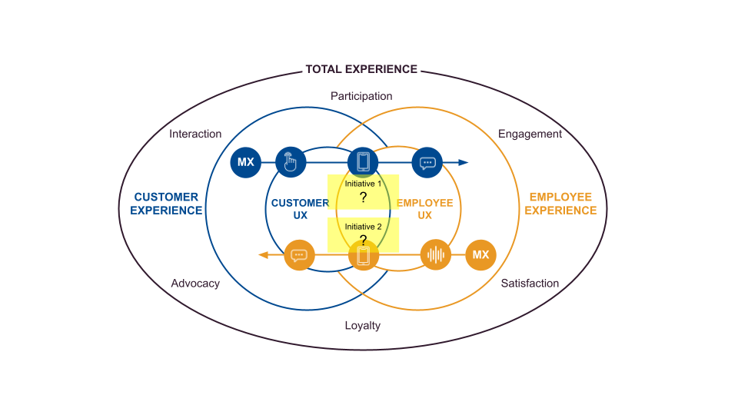
Lastly, zoom out to consider Initiatives 1 and 2 together.
- Are there any interactions or handoffs between the two experiences you designed?
- Will customers or employees interact with both systems?
This critical step is often overlooked in the real world, and it’s where users may experience discrepancies in the overall brand-level user experience.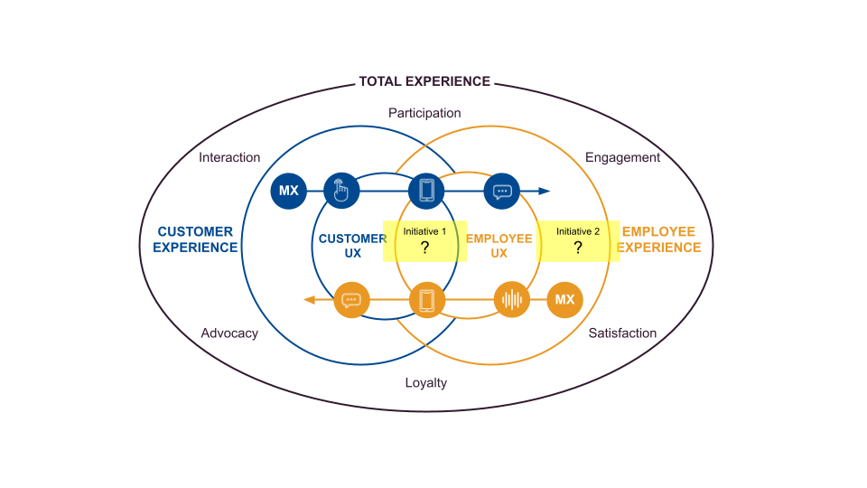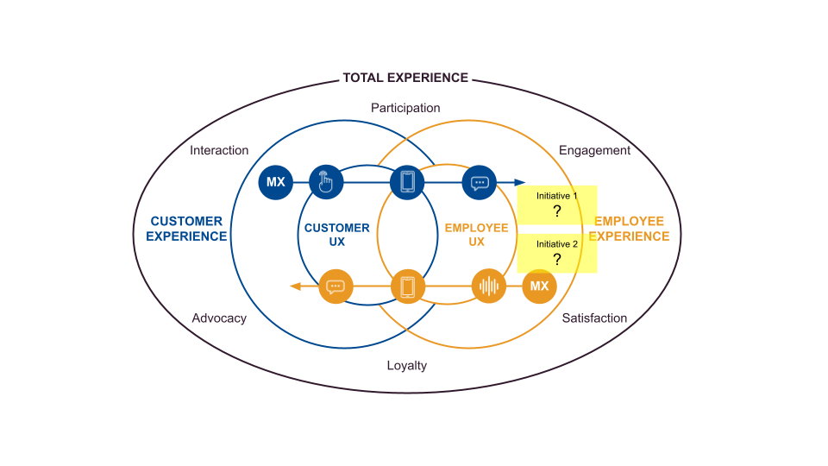

D. Interface Visualization Prompt
Now let’s bring all the insights you’ve built up to this point to life! Use the references below to visualize your Agentic AI experience.

Reference:
- Module 5 Designing for Trust: Human Side | AI Side | Principles
- Module 7 Designing Agentic AI Experiences: The Bridge Between Tech and Users
- Module 7 Agentic AI Experiences in Action

Step 1. Low-fidelity Sketches
Visual Workspace:

Step 2. High-fidelity Prototype: Selected Set of Screens
Now, use any AI-assisted prototyping tool (e.g. Lovable, Vercel) to turn your low-fidelity sketches into a high-fidelity screen/interface for the agentic AI experience you designed. Create at least one prototype with a set of selected screens that clearly visualizes your concept. Focus on the key UI elements and user interactions to bring your idea to life. The selected prototype screens should represent the key essence of your initiative.

Initiative 3: Emotionally Intelligent AI Experience
Focused on medium-term Innovation Incubation (typically 3-5 years)

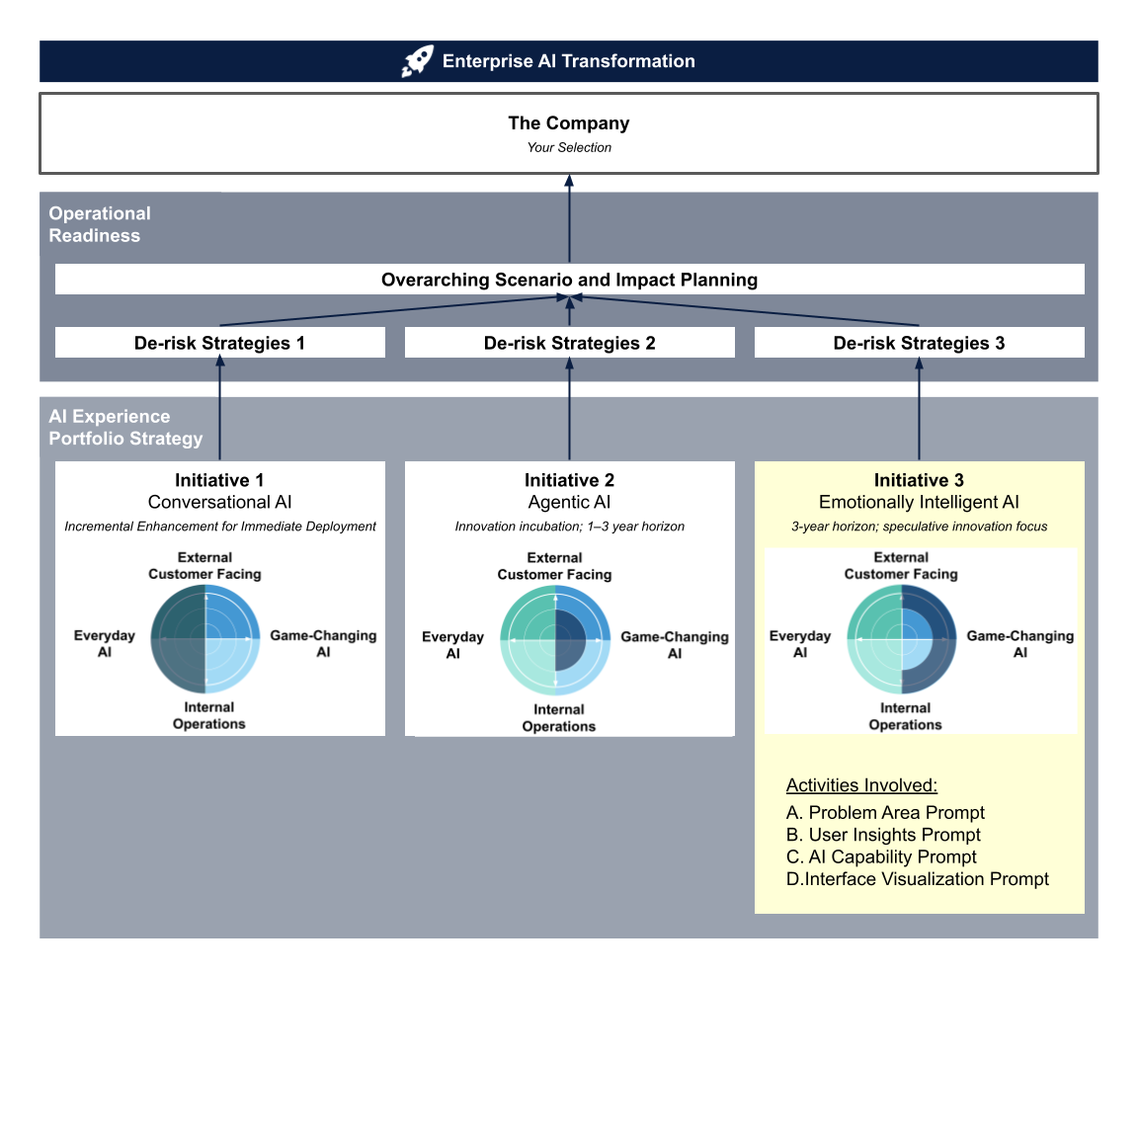

Introduction
While Initiatives 1 and 2 focus on AI that can launch immediately or in the near-term, Initiative 3 asks you to design an experience powered by Emotionally Intelligent AI, one of the field’s most sensitive domains. The EU AI Act classifies most emotion-recognition systems as “high-risk,” and it bans certain applications of them, reflecting heightened concerns around privacy, bias, and psychological impact.

Even so, the Act restricts deployment, not discovery. Article 2(6) expressly exempts research and development, enabling companies to keep refining Emotion AI in labs, pilots, and sandboxes. Industry leaders still design and improve these systems with an eye on the future. Therefore, your selected company’s executive leadership team has established a longer 3-5-year innovation-incubation window. By investing in careful R&D today, they expect the company aims to be ready with mature, ethically tested Emotionally Intelligent AI solutions once society and regulators decide the time is right for their responsible use.

Purpose
Here you shift from “can we build it?” to “should we release it?” You will design an Emotionally Intelligent AI concept that remains safely in an R&D sandbox while the legal landscape stabilizes. The exercise strengthens three strategic-foresight muscles new to this simulation, scanning for rule changes, planning phased pilots, and setting measurable bias-reduction targets, alongside core responsible-AI craft (explainability, consent UX, cultural sensitivity). You’ll also learn to navigate ambiguity and build solution maturity over a three-to-five-year runway. Together, these capabilities round out the AI-UX transformation narrative you began in Initiatives 1 and 2, equipping you to steer high-risk innovation from lab to future market readiness.

A. Problem Area Prompt
In this section, you will define your problem space for emotionally intelligent AI.

You may freely explore Emotion Recognition concepts in this workbook (and companies can do so in lab or sandbox environments in the real world) even if those same use cases are banned from deployment under Article 5(1)(f) of the EU AI Act today.

If your final use case selection is in workplaces or classrooms, which are currently prohibited for real-world use. Label the following disclaimer in your deliverable.

Disclaimer: The use case I have selected for Initiative 3 (Emotion AI in workplaces or classrooms) is currently listed as prohibited under Article 5(1)(f) of the EU AI Act. This concept is presented solely for research and sandbox purposes and must not be deployed in any live environment under current law. Should this project advance toward production, please engage our company’s legal and compliance teams to navigate applicable regulations and avoid potential liability.

Reference:
- Module 3 The Skeleton of a Great AI Experience: Pillar 1 Real-World Needs | Pillar 2 Technology
- Module 8 Designing Emotionally Intelligent AI Experiences: Start with Real-World Needs
- Module 8 Emotionally Intelligent AI Experiences in Action
- Module 8 Designing Emotionally Intelligent AI Experiences: The Bridge Between Tech and Users

Step 1. Business/User Problem Mapping
Use the thinking prompts below to brainstorm use cases where emotionally intelligent AI could deliver the most value. It could be one of the following cases:
- Customer-facing:
  - In what ways might an Emotionally Intelligent AI–driven feature improve satisfaction or loyalty—for example, by offering empathetic guidance, customizing recommendations, or simplifying a task when frustration is detected?
- Employee-facing
  - How could Emotionally Intelligent AI improve employee well-being in their daily workflows (e.g. back-to-back meetings, high call volumes, or tight deadlines)?
- Hybrid workflow
  - Identify a workflow where both customers and employees interact (e.g. retail checkout, call center ticket resolution, bank-branch service). Where do emotional bottlenecks arise for each side? In what ways might detecting both sides’ emotions lead to tangible improvements—like dynamically rerouting customers to less busy agents or prompting a manager to step in before conflicts escalate?

 | Emotionally Intelligent AI Solution Idea |  | Proposed Value
Customer-facing | 1.
 | 2.
 | 3.
 | 4.
 | 5.
Employee-facing | 1.
 | 2.
 | 3.
 | 4.
 | 5.
Hybrid Workflow | 1.
 | 2.
 | 3.
 | 4.
 | 5.

Step 2. Early Check Filter
Because Emotionally Intelligent AI is labeled high-risk, it’s crucial to validate your brainstorms early. Take your top three ideas that seem most valuable for your company and apply the following quick checks. This filtering will help you narrow down to the most appropriate use case for continuing the design journey.

Emotion Necessity Check
- Is emotion a crucial component of this experience?
- Describe why this interaction or service relies on emotional context (e.g. banking decisions are deeply personal, healthcare involves complex emotional factors).
- How do users currently express or experience emotion at key touchpoints?
  - Ask yourself: when your customers interact with this product/service, what triggers an emotional response (e.g. anxiety during checkout, relief after customer support, pride in ownership)?
  - Think beyond surface-level emotion—consider subtler reactions: does a banking user feel embarrassed asking for a loan? Does a patient feel vulnerable when sharing health data?
- What would it look like if emotional signals were missing or ignored?
  - Consider: if your system never acknowledged a user’s frustration or excitement, how would that degrade their experience?
  - Imagine a scenario: a frustrated customer completes a support ticket without any empathy—what new pain points emerge?

Comparative & Contextual Check
- How do analogous companies or competitors handle emotion in similar contexts?
  - Research: find 2–3 industry peers or analogous services and note whether they explicitly cater to emotional needs. For example, how does a rival bank communicate trust and empathy compared to yours?
- In your industry, what emotional norms or taboos exist, and how might they vary by segment?
  - Reflect: For example, in a healthcare setting, patients expect confidentiality and empathy; in finance, customers expect security and respect. How do cultural, generational, or socioeconomic factors shape what is “acceptable” for emotion-driven features?
  - Drill down: would a younger demographic value a playful, emotion-aware chatbot, while older users find it intrusive?
- How does your company’s brand personality (e.g. tone, values, reputation) influence the way emotion features are or should be presented? For instance, a luxury brand may emphasize calm and exclusivity, whereas a mass‐market brand might focus on playful engagement.
- Within your target markets, how do cultural norms around expressing emotion vary? For example, is it more acceptable to show vulnerability in one region versus another? How might that shape the solution scope?
- Have you considered cultural and individual differences in emotional expression, avoiding the assumption that everyone shows or interprets emotions the same way

Cultural Check
- Within your target markets, how do cultural norms around expressing emotion vary?
  - For example, is it more acceptable to show vulnerability in one region versus another? How might that shape the solution scope?
  - Which emotional topics or triggers are taboo or sensitive in certain cultures, and does your use case encounter these? For example: In certain cultures, ​​openly discussing depression can carry stigma.
- Have you considered cultural and individual differences in emotional expression, avoiding the assumption that everyone shows or interprets emotions the same way.
- Are there cultures where people are taught to mask certain emotions (e.g. not showing anger in public)? How would your AI handle subdued or neutral expressions that mask inner feelings?
  - For example: In certain cultures, customers may keep a neutral face when frustrated, preferring direct words over visible displays. If your AI relies on overt facial cues to detect frustration during loan inquiries, it might miss subtle signs and fail to offer empathetic assistance.

Step 3. Alignment & Use Case Selection
Reflection:
What is your final use‑case selection? Describe it clearly and explain why Emotionally Intelligent AI is the best fit. Then note how the idea aligns with company strategy, outline expected impact, and capture key unknowns/risks.
- Internal efficiencies
- Customer-facing Support
- Missed opportunity


B. User Insights Prompt
Now that you’ve selected a key use case and completed:
- Emotion Necessity Check to confirm that Emotionally Intelligent AI can truly help
- Comparative & Contextual Check to validate it fits your company and industry
- Cultural Check to incorporate relevant norms and sensitivities
The next step is ensuring the use case is grounded in real human requirements and values. This foundation will then inform which Emotionally Intelligent AI technologies to apply. By following this sequence, your concept will prioritize emotional value and ethical integrity for users, and then leverage technology in service of those goals, rather than the other way around. This approach reflects both industry best practices and prudent risk management in a domain as sensitive as Emotionally Intelligent AI.

Reference:
- Module 1 Who Are The Users?
- Module 1 Meet Your Users Where They Are: Shifting User Behaviors | Rising Expectations
- Module 2 Enterprise AI UX Transformation Playbook: Move 3 User Insights Frontloading
- Module 2 Trade-off: AI vs. Comfort Zone
- Module 3 The Synthetic Persona Tool: Bringing “Meet Your Users Where They Are” to Life
- Module 8 Designing Emotionally Intelligent AI Experiences: The Bridge Between Tech and Users: Machine Empathy Balance

Step 1. Who are your users?
- Internal user (e.g. employee, support agent, technician, sales)
- External user (e.g. customer, partner, patient)
- Both

Step 2. User Profile
Use the space below to outline the typical behaviors, motivations, and pain points of this user in the selected problem area:

Behavior Patterns:
Do users carry over any behaviors from previous technological eras or systems when engaging with this workflow?

Expectations:
What new expectations—around speed, personalization, accuracy, or autonomy—have users formed due to the growing presence of AI in similar experiences?

AI Familiarity & Attitudes:
How comfortable or skeptical is this user group toward AI-driven experiences?

Step 3. Identity Layers
Use the space below to outline the user’s social persona, data-double, and real-person nuances, including cultural norms and online versus offline performance:

Social Persona:
- How does your user present themselves publicly or online (e.g. professional on LinkedIn, playful on Instagram)?
- What performance elements do they adopt to shape others’ perceptions?

Data-Double:
- What key data points does AI see about your user (search history, purchases)?
- What performance elements do they adopt to shape others’ perceptions?

Inner Voice & Nuances:
- What are your user’s inner thoughts, fears, and values that aren’t visible in their digital profile (e.g. “I’m anxious but hide it behind a calm facade”)?
- What private motivations or concerns drive their behaviors?

Cultural Context & Social Performance:
- What cultural norms shape how your user expresses emotion (e.g. is showing vulnerability taboo)?
- How might your user perform differently online versus offline, and why?

Step 4. Synthetic Persona
Based on your analysis, use AI to generate a synthetic persona that represents the user you’re designing for. If you’ve identified multiple user groups, generate one persona for each.

  Find a picture that represents your user in the workflow. It doesn’t need to be a happy, smiling image—the focus is on realistically conveying the user’s challenges.  Quote that represents their mindset:  “  “  Notes or observations: | Persona Name:  Role / Background:  Goals (related to this problem area):  Frustrations / Barriers:  Tech Comfort / AI Familiarity:  - High familiarity and trust in AI  - Limited experience but open-minded  - Skeptical or cautious  - Other: _____________________________  Emotional Behavior Cues:  Cultural Expression Pattern

Step 5. Confirm Strategic Alignment
Before moving forward, pause to confirm that this user opportunity aligns with your company’s broader strategic goals.

Thinking prompts:
- How does this Emotionally Intelligent AI use case support your company’s long-term vision and mission?
  - Think about whether helping users manage stress or build empathy aligns with your organization’s stated goals (e.g. “be the most customer-centric brand” or “innovate responsibly in healthcare”).
- Does this Emotion AI concept differentiate you from competitors and reinforce your unique strengths?
  - Identify how it leverages your company’s core capabilities (data assets, domain expertise, distribution channel) in a way that others can’t easily replicate, ensuring a sustainable advantage.
- How will investing in R&D for this Emotion AI use case advance other strategic initiatives?
  - Think about whether developing these capabilities (such as advanced sentiment analysis or multimodal emotion detection) might also serve future products—ensuring that today’s incubation effort builds capabilities you can reuse elsewhere.

Lastly, zoom out to consider Initiatives 1, 2, and 3 together.
- Are there any interactions or handoffs between the three experiences you designed?
- Will customers or employees interact with more than one system?
- Do they involve the same user groups, or will distinct user groups interact within a shared workflow (e.g. a sales agent using the conversational AI might hand off to a technician in the multi-agent workflow)?
This critical step is often overlooked in the real world, and it’s where users may experience discrepancies in the overall brand-level user experience.
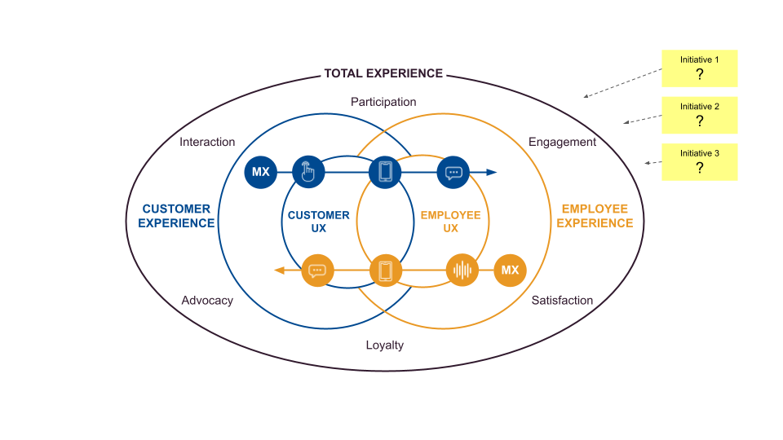

C. AI Capability Prompt
Now that you’ve understood your users’ emotional needs, it’s time to identify which AI capabilities will bring your emotionally intelligent experience to life. Concentrate on what the AI can sense and respond to, such as sentiment analysis of text or voice, dynamic empathy scripts, or facial-expression recognition, so that users feel understood and supported. This is not about coding or cloud stacks; it’s about the value these capabilities deliver.

Constraint Reminder: And because we’re working on a 3–5-year innovation incubator, select emotion-AI functions that can be refined in R&D or regulatory sandboxes (for instance, layering in a real-time mood detector on your app) to achieve long-term impact as technical reliability and guidelines evolve.

Reference:
- Module 2 Trade-off: AI vs. Comfort Zone
- Module 3 The Skeleton of a Great AI Experience: Pillar 2 Technology
- Module 8: Designing Emotionally Intelligent AI Experiences: Mapping Use Cases to AI Capabilities

Step 1. Identify AI Capabilities that Support the Experience
Which capabilities will allow your Emotionally Intelligent AI to support the selected workflow and user needs? Select those that apply:
- Emotion-Aware Natural Language Understanding (NLU)
- Empathetic Response Generation (Generative AI)
- Multimodal Sentiment Analysis
- Emotion-Predictive Assistance
- Facial Expression & Body Language Analysis
- Speech Emotion Recognition
- Expressive Text-to-Speech
- Other: _____________________________

Step 2. Justify Your Selection
Your rationale:
Why are these the right capabilities to support your users and use case? Briefly describe how this selection supports your users in the identified problem area for your company.

Step 3. Feasibility Check
Do these capabilities align with the incubation innovation, 3-5 years goal?
- Yes
- No (If not, revise your scope to better fit the funding and deployment constraints)

What trade-offs or simplifications will you make to keep this proposal viable?

D. Dark-Side De-risking Prompt
Now that you’ve scoped which Emotion AI capabilities will power your concept, it’s vital to pause and confront potential downsides before sketching any screens. The Dark-Side De-risking Prompt sits here to help you identify where emotion sensing could go awry—whether through misinterpretation, unintended manipulation, or privacy breaches. By examining these risks now, you’ll ensure that your interface design later is grounded in responsible, ethical insights. This step bridges your technical ambition with user well-being, readying you to visualize a safer, more trustworthy user experience.

Reference:
- Module 5 Designing for Trust: Human Side | AI Side | Principles
- Module 8: Topic Overview – Reading Material: Emotionally Intelligent Design: Rethinking How We Create Products, Chapter 2 “The History And Future Of Emotional Design”, Section “The Dark Side of Emotion AI”
- Module 8: Designing Emotionally Intelligent AI Experiences: The Bridge Between Tech and Users

Step 1. Flaws in Emotionally Intelligent AI Sensing & Logic
Evaluate the underlying assumptions and potential inaccuracies in your Emotion AI’s sensing and reasoning. Even advanced emotion recognition algorithms can misinterpret human feelings due to flawed logic, lack of context, or biased data. In this exercise, you’ll identify where your concept might get it wrong, from over-simplistic mappings of expressions to emotions, to cultural biases in training data, and consider the consequences of those errors.

Thinking Prompts:
- Detection Assumptions: What signals (facial expressions, tone, text, etc.) does your AI rely on, and what assumptions is it making about them? Could those be wrong or too simplistic?
  - For example, does a smile always mean “happy”? What about cultural or individual differences that might confuse the AI?
- Bias & Blind Spots: How might biased datasets or models skew the AI’s emotional readings? Consider if it might perform worse for certain groups or contexts
  - For example, the system might misread the expressions of people from a culture under-represented in the training data. What emotions or nuances might it consistently miss or mislabel?
- Error Consequences: If the AI misclassifies an emotion, what could go wrong? How might a false “angry” or “calm” reading impact user experience or decisions? Identify a scenario in your use case where a sensing error could lead to confusion, injustice, or harm.

Step 2. Human Behavior Risks
Reflect on how users or those affected might change their behavior in response to your Emotion AI, beyond what the AI itself does. People often react to sensing tech in unexpected ways: they might start “playing to the algorithm” (showing emotions they think will get favorable outcomes), or they might place too much trust in the AI’s judgments, diminishing their own emotional skills. In this exercise, you’ll anticipate these human-side risks, from users faking feelings to please the AI, to becoming over-reliant on the AI’s emotional intelligence at the cost of their own.

Thinking Prompts:
- Performing for the AI: If users know the system is watching their emotions, how might they alter their behavior? Brainstorm if people might fake, exaggerate, or suppress feelings to “game” the AI.
  - For example, an employee forces smiles and upbeat tone because a dashboard rates their mood, or a student tries to appear calm to avoid triggering an alert. Workers in one study felt anxiety about being under emotional surveillance and tried to “make the system read them favorably”. Would such performance undermine the authenticity or effectiveness of your experience?
- Overtrust & Dependence: Could users become over-reliant on the AI’s emotional readings or support?
  - For instance, would they trust the AI’s assessment of how they or others feel more than their own judgment? Imagine someone leaning on a mood-predicting app to tell them if they’re happy, or over-sharing with a “therapist bot” believing it understands them perfectly. What are the risks if users stop developing their own emotional awareness or judgment because they trust the machine implicitly (a sign of overreliance on machine sensing)?
- Social Side-Effects: How might the presence of the AI affect human-to-human interaction in your scenario? Consider if people might communicate less directly about emotions or lose some empathy because the AI intermediates their emotional exchanges. Does your concept risk creating distance in relationships?
  - For example, a family relying on an AI to monitor each other’s moods rather than talking openly? Identify any potential human connection that might weaken and how you could address that.

Step 3. Real-World Misuse & Privacy Risks
Examine how your Emotion AI concept could be misused or have unintended harmful applications if it fell into the wrong hands or was deployed irresponsibly. Emotion AI is powerful, which means it can be exploited for manipulation, surveillance, or other “dark side” outcomes if not carefully controlled. In this exercise, you’ll step into the shoes of a critic or malicious actor: think about how the emotional insights or data from your system might be leveraged in ways that invade privacy, deceive or control people, or erode human relationships.

Thinking Prompts:
- Emotional Manipulation: How could someone use your AI’s emotion-sensing capability to influence or exploit users?
  - For instance, could a marketer or app use detected moods to push products on people when they are sad or vulnerable? Could your AI’s feedback be used to nudge users’ feelings in a predatory way?
- Erosion of Trust/Intimacy: Could over-reliance on this AI cause a loss of human intimacy or trust? For example, would managers or family members start relying on emotion metrics instead of honest conversation, possibly harming genuine relationships? Think of whether your AI might unintentionally become a crutch that replaces human empathy or reduces face-to-face interaction in its intended setting.
- Surveillance & Privacy: What privacy invasions might be possible with the data your system collects? Consider if your concept involves cameras, microphones, or biosensors constantly monitoring emotions – how might that be misused as a form of emotional surveillance? Are users fully aware and consenting to this data use, and who might try to access these sensitive emotion readings?

E. Interface Visualization Prompt
Now let’s put all these insights you’ve gathered into action! Use the references below to visualize your Emotionally Intelligent AI experience.

In this initiative, not only do you need to create the interface that represents the essence of your concept, but you should also design a second screen showcasing a selected dark pattern identified in Exercise D, along with your fallback mechanism to safeguard the experience.

Thinking Prompts:
- For example, in a retail website’s Emotion AI assistant that detects frustration in a user’s tone, a savvy shopper might force an aggravated tone to trigger a discount offer, manipulating the AI’s assumption that frustration equals “need discount.”
  - Safeguard fallback mechanism: When the AI detects frustration in vocal tone, what secondary confirmation step or multi‐modal check can you build into the interface to verify intent before offering a discount?
    - Potential solution: “It sounds like you might be upset. Did you need help with your order, or would you like to see exclusive offers? [I need help] [Show me deals]”
    - Why it’s a safeguard fallback mechanism: By adding a deliberate intent validation step—“Are you sure?” (e.g. “Did you need help or want deals?”)—the design introduces friction for explicit confirmation, thereby preventing manipulative tactics (e.g. feigning frustration solely to obtain discounts) and maintaining trust.

Reference:
- Module 5 Designing for Trust: Human Side | AI Side | Principles
- Module 8 Designing Emotionally Intelligent AI Experiences: The Bridge Between Tech and Users
- Module 8 Emotionally Intelligent AI Experiences in Action

Step 1. Low-fidelity Sketches
Visual Workspace:

Step 2. High-fidelity Prototype: Selected Set of Screens
Now, use any AI-assisted prototyping tool (e.g. Lovable, Vercel) to turn your low-fidelity sketches into a high-fidelity screen/interface for the Emotionally Intelligent AI experience you designed. Create at least one prototype with a set of selected screens that clearly visualizes your concept. Focus on the key UI elements and user interactions to bring your idea to life. The selected prototype screens should represent the key essence of your initiative.

Operational Readiness

1. De-risking the Portfolio

Introduction
In the real world, successful AI transformation hinges on proactive risk management. Companies de-risk every idea and initiative by testing throughout the AI lifecycle. In this module, you will continue the simulation with your chosen company: take the three AI initiatives you proposed and work through targeted exercises to craft tailored de-risking strategies for each one.

Risk management is never one-size-fits-all. Because each of your three AI experiences tackles different challenges, each will call for a distinct testing method. The prompts in this section will guide you to the most suitable strategy for each initiative.

Purpose
The exercises here are critical because it lets you practice applying risk management techniques learned in the course to your own project. By doing so, you’ll be better prepared to handle real-world situations in AI development. It encourages you to validate key assumptions early, making your final solution more trustworthy and effective.

De-risking Strategy for
Your Initiative 1: Conversational AI
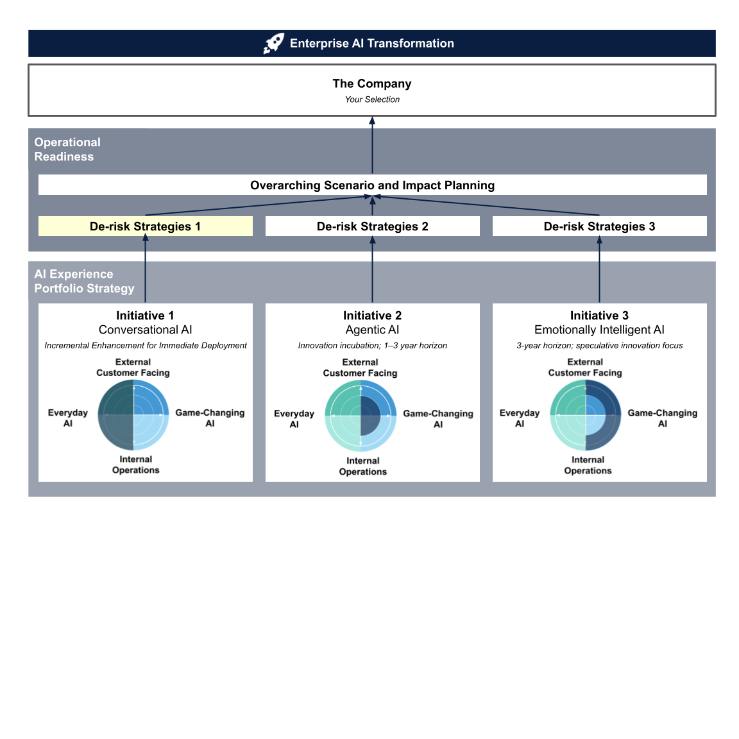

A. Risk Profile
Before you can mitigate risk, you must first establish its risk profile and estimate the level of exposure. This is where the Lean Experiments methodology plays a crucial role. In practice, when a team is uncertain, they run a Lean Experiment as soon as an idea emerges to gauge potential risks.

In this individual exercise, you won’t have cross-functional partners to work with, so we’ve scoped the Lean Experiments approach to just the Jobs-to-Be-Done assumption dump. Capturing assumptions from multiple angles gives you a clear picture of how risky this initiative is. These insights will guide your choice of testing methodologies.

Reference:
- Module 5 Designing for Trust: Human Side | AI Side | Principles
- Module 9 Early AI Idea Fit: Lean Experiments: Jobs-to-Be-Done | Assumption Dump | Lean Experiments in Action

Step 1 Assumption Dump
Experience Goal: | Guiding Prompts:  - What is your conversational AI experience trying to achieve for your users?  - What benefits will users gain by using this conversational AI?  - What specific business impacts (e.g. cost savings, efficiency gains, user satisfaction) do you hope this experience will drive?  Sample Case: Provide an internal HR helpdesk chatbot that can understand employee queries about benefits, policies, and procedures, deliver accurate, timely answers 24/7, and seamlessly escalate complex issues to human agents when needed. | Your Conversational AI Initiative:
Risk-Category Assumptions Capture:  User Need Fit | Guiding Prompts:  - What core “job” are your users trying to get done when they reach out to the conversational AI?  - How do your users currently solve this need, and where does that process fall short?  - In what scenarios might your users bypass the conversational AI entirely, and why would that happen?  Sample Assumptions for the HR Case:  - Employees expect immediate answers on PTO balances.  - Staff want to submit tickets via chat rather than email | Your Assumptions:

Risk-Category Assumptions Capture:  Business Value | Guiding Prompts:  - What core business problem does your conversational AI solve, and why does it matter to the organization?  - Who are the key stakeholders/participants whose priorities shape the expected value, and what outcomes will convince them?  - What functional “job” is the business “hiring” this conversational AI?  Sample Assumptions for the HR Case:  - Faster ticket resolution lowers turnover costs.  - Automating FAQs improves operational efficiency. | Your Assumptions:
Risk-Category Assumptions Capture:  Capability Fit | Guiding Prompts:  - Could a simpler, non‑AI or rules‑based solution achieve the same outcome more efficiently, and how would you know?  Sample Assumptions for the HR Case:  - This problem is best solved by a conversational AI bot. | Your Assumptions:

Other Assumptions | If you identify additional assumptions beyond the risk categories while working through the exercise, capture them as well! | Your Assumptions:

Step 2 Risk Profile Assessment
Now, map the assumptions you identified in Step 1 onto the 2×2 matrix below. This priority matrix compares the degree of uncertainty against the potential impact on success, helping you pinpoint which assumptions pose the greatest risk.
- Y-axis: If the assumption proves wrong, how likely is it to kill the idea or product?
- X-axis: How much evidence do you have to back up the assumption?

For the X-axis (evidence) ask yourself: for the sample assumption “Employees expect immediate answers on PTO balances,” how did you form this belief? Is there a survey confirming this pain point? In this simulation, you won’t have access to the company’s internal data, so rely on publicly available information and make an educated guess.

After mapping your assumptions, review the chart: how many fall in the top-right quadrant, those with little evidence that, if proven wrong, would likely kill your idea or product? The more assumptions that fall into that area, the higher the risk profile for this initiative.

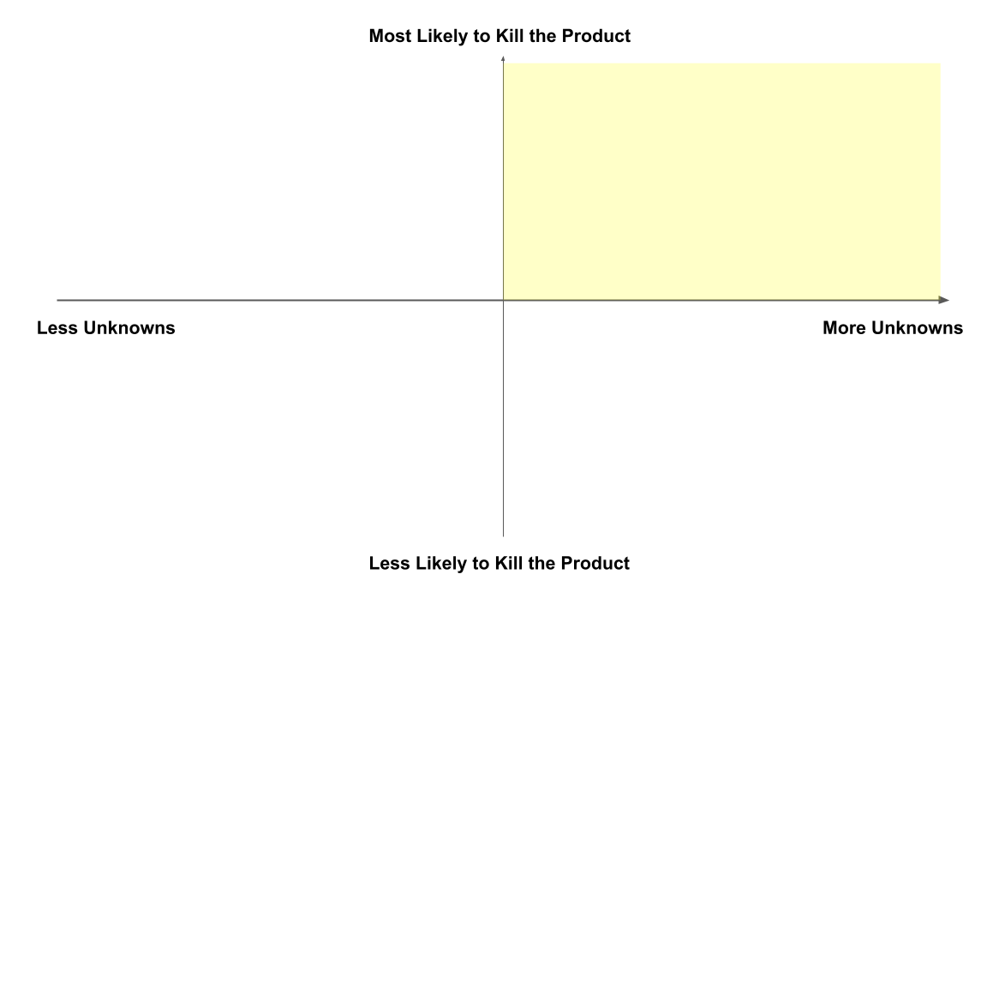

B. De-Risking Method Selection
Reference:
- Module 5 Designing for Trust: Human Side | AI Side | Principles
- Module 9 Early AI Idea Fit: Lean Experiments: Jobs-to-Be-Done | Assumption Dump | Lean Experiments in Action
- Module 9: Proof of Value Before Launch: Pilot Programs
- Module 9: Early Post-Launch Value Tuning: A/B Testing
- Module 9: Post-Launch Always-On Guardrails: Continuous Monitoring & Feedback Loop

Based on your risk profile and the four methodologies introduced at different stages of the AI initiative cycle, how many testing methods will you employ for Initiative 1, Conversational AI?
- Lean Experiments
- Pilot Programs
- A/B Testing
- Continuous Monitoring & Feedback Loop

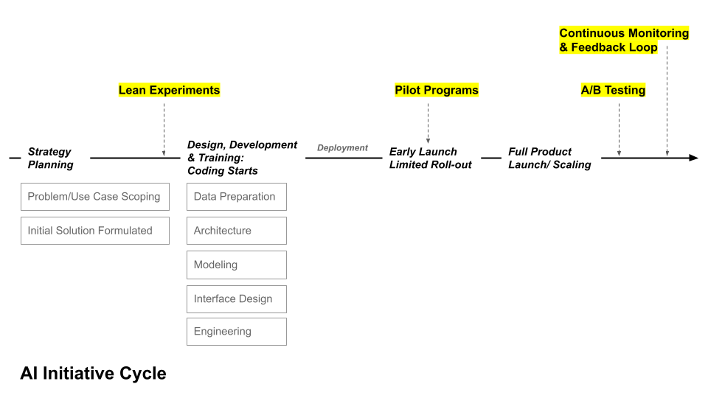

Your justification for selecting de-risking methods:

C. Validation Focus
Reference:
- Module 5 Designing for Trust: Human Side | AI Side | Principles
- Module 9 Early AI Idea Fit: Lean Experiments: Jobs-to-Be-Done | Assumption Dump | Lean Experiments in Action
- Module 9: Proof of Value Before Launch: Pilot Programs
- Module 9: Early Post-Launch Value Tuning: A/B Testing
- Module 9: Post-Launch Always-On Guardrails: Continuous Monitoring & Feedback Loop

Now, for each testing method you’ve selected, decide what validation focus you need at that stage of the AI initiative cycle: what evidence will unlock the next gate and move your idea toward full-scale launch and operationalization?

You can skip the testing method exercise box if you did not select that method for this initiative.

Method: Lean Experiments
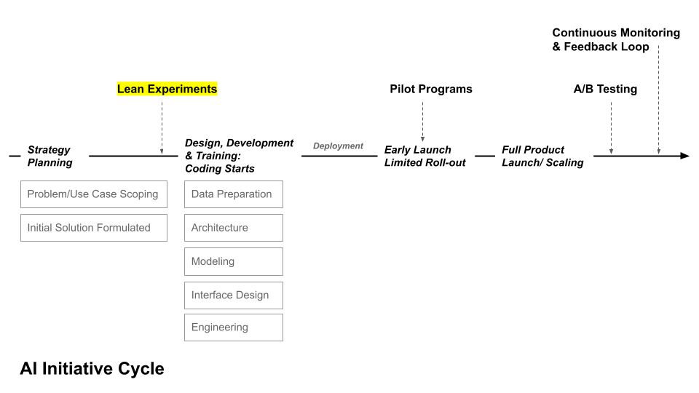

- Desirability: Do people need/want this AI?
Your analysis:

- Viability: Does it make business sense?
Your analysis:

- Capability fit: Could a simpler, non-AI solution work just as well, or does AI provide unique value that justifies its complexity?
Your analysis:

Method: Pilot Programs
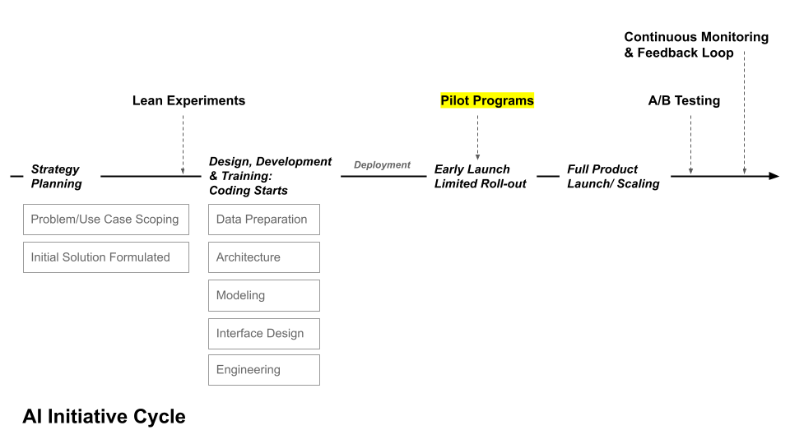

- Business Impact:
  - Which single business metric must this pilot improve for leadership to green-light full rollout (e.g. support cost per contact, average resolution time, conversion rate)?
  - What leading indicator during the pilot (e.g. adoption rate) will signal early momentum, and what lagging indicator (e.g. quarterly cost reduction) confirms long-term impact?
  - What business outcome would force us to pivot or stop if the pilot underperforms (e.g. negative CSAT, compliance overhead)?
Your analysis:

- User Adoption & Trust:
  - What early-usage threshold (e.g. percentage of target users who try the conversational AI in week 1) will signal meaningful adoption?
  - How will you measure whether users trust the conversational AI’s answers (e.g. post-interaction confidence score, repeat usage rate, escalation frequency)?
  - Which qualitative signal (e.g. verbatim feedback, open-text survey comments) will tell you why users embrace or avoid this conversational AI?
  - How will you detect and respond to moments when users bypass or abandon the conversational AI, indicating a trust gap?
  - Which cohort or scenario should you monitor most closely (e.g. first-time users, complex queries) to uncover hidden adoption barriers early?
Your analysis:

- Scalability & Operational Fit:
  - If pilot traffic triples, can the system maintain response time and accuracy targets without manual intervention?
  - What operational hand-offs (escalations, monitoring, retraining) must work flawlessly at higher volumes, and how will you measure their reliability?
  - What early warning metrics (e.g. queue length, failed intents per minute) will signal scalability or operational-fit issues before they impact users?
Your analysis:

Method: A/B Testing
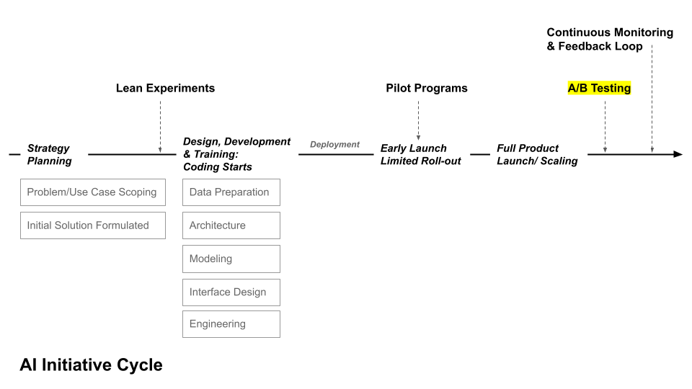
- Business‐Value Delta:
  - When sketching out the idea for Initiative 1, do you have a different option/variant you’re unsure will best move the needle toward achieving your experience goal?
  - Which KPI (e.g. revenue, conversion rate, or cost per acquisition) would you measure to determine whether the second variant creates a statistically significant lift large enough to justify rolling the change out fully?
Your analysis:

- User-Experience Guardrails:
  - Which secondary UX metric (e.g. CSAT, response latency, error-rate, or dropout rate) must hold steady, or improve, while that second variant pursues its business lift?
  - How will you compare usage patterns between variants to catch subtle UX regressions, such as longer task duration or higher abandon rates, that raw conversion numbers might hide?
  - Which accessibility or inclusivity checks (e.g. voice accuracy for accents, readability, language support) must remain equal across variants to avoid harming particular user groups?
Your analysis:

- Causal Confidence & Risk Limit:
  - What post-experiment checks (e.g. novelty effects, seasonality, instrumentation errors) will we perform to validate causal claims?
  - If results are ambiguous, what follow-up experiment or segmentation analysis will we run before making a launch decision?
Your analysis:

Method: Continuous Monitoring & Feedback Loop
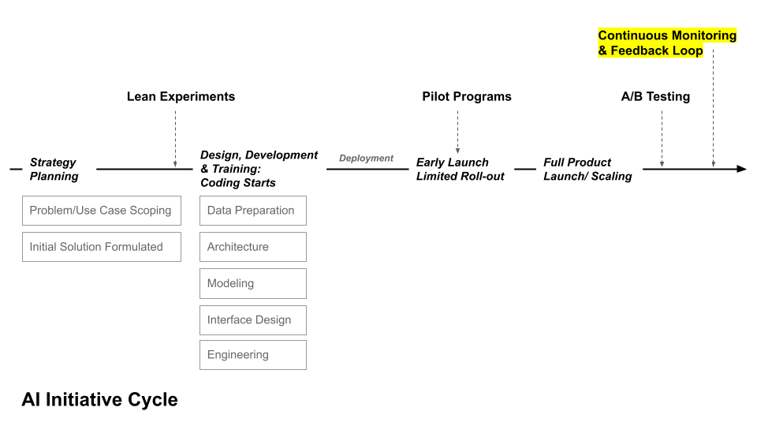

- Performance & Drift Alerts:
  - What early-warning indicators (e.g., sudden spike in fallback responses, unusual escalation patterns) suggest the conversational AI’s understanding of user queries is drifting?
  - Which business or compliance risks (e.g. biased answers, policy violations) require separate alert channels, and how will you verify alerts are calibrated to avoid false positives?
  - How will you log user feedback corrections (‘thumbs-down,’ manual edits) and convert them into training data to reverse drift?
  - What periodic ‘health review’ cadence (weekly, monthly) will you use to validate that alert thresholds remain aligned with evolving business and user expectations?
Your analysis:

- Business-KPI Guardrails:
  - Which primary business KPI (e.g. cost per interaction, conversion rate, retention) must remain within a safe range, even as traffic and usage patterns evolve?
  - How will we correlate surges in fallback or escalation rates with business outcomes to ensure hidden UX issues aren’t eroding revenue or efficiency?
  - Which cohorts or segments (new users, high-value customers, specific markets) must we track separately to catch business-KPI dips that aggregate data might hide?
Your analysis:

- Fairness & Compliance Watch:
  - Which demographic or usage segments should we track separately to ensure the conversational AI’s accuracy, tone, and outcomes remain equitable over time?
  - What automated checks will scan chat logs for policy violations or non-compliant language, and who reviews flagged incidents?
  - What user-facing mechanism (e.g. ‘report a problem’ button) captures real-world fairness or privacy complaints, and how quickly must we respond?
Your analysis:

De-risking Strategy for
Your Initiative 2: Agentic AI
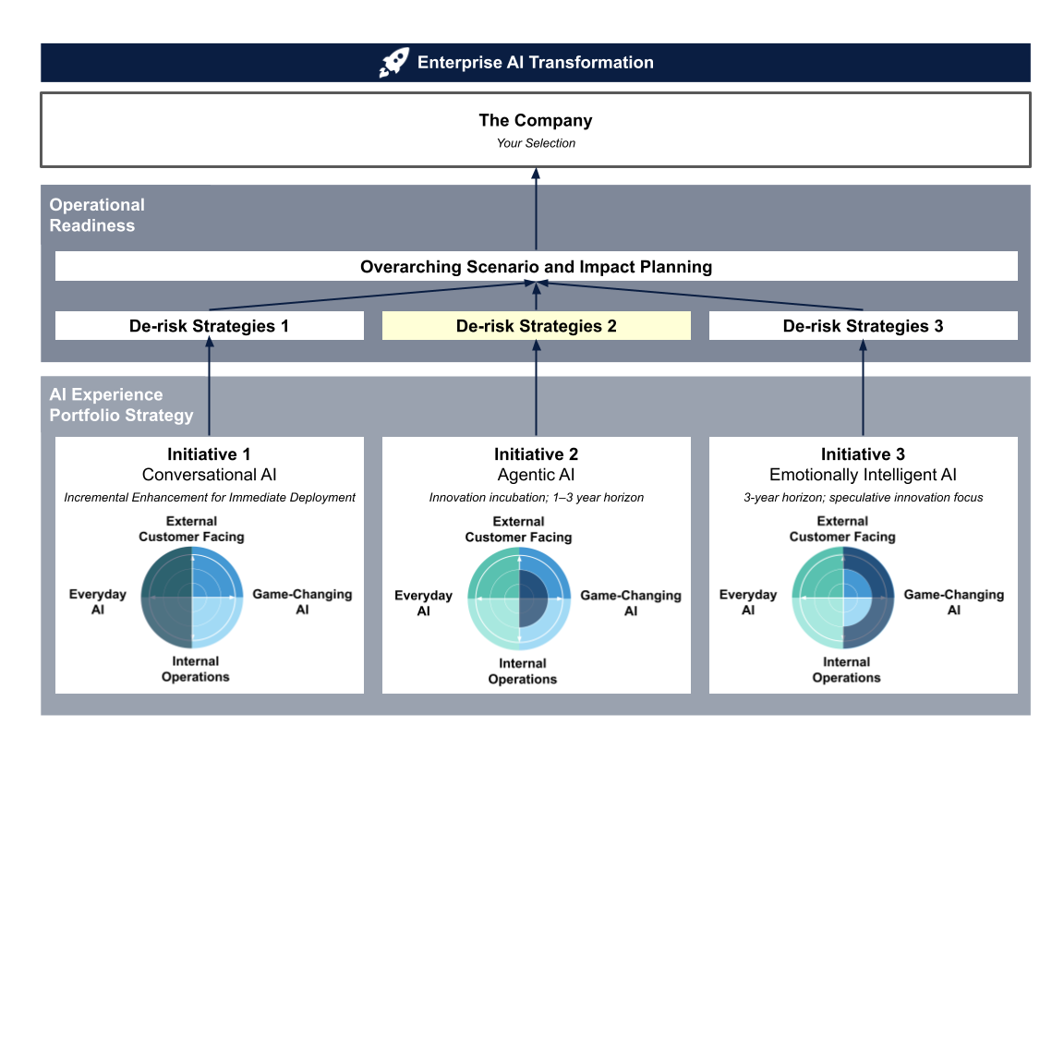

A. Risk Profile
After completing the de-risking strategy for Initiative 1, you should now be familiar with the process and exercises involved.

Next, you’ll apply the same de-risking approach to Initiative 2, Agentic AI. The exercises remain the same, but your considerations will differ because of the distinct nature and maturity of this AI capability.

Reference:
- Module 5 Designing for Trust: Human Side | AI Side | Principles
- Module 9 Early AI Idea Fit: Lean Experiments: Jobs-to-Be-Done | Assumption Dump | Lean Experiments in Action

Step 1 Assumption Dump
Experience Goal: | Guiding Prompts:  - What is your agentic AI experience ultimately trying to achieve for your users?  - Which coordinated agent tasks must work together to deliver that core outcome, and why is autonomy critical?  - What unique user benefits emerge when multiple agents collaborate versus a single AI or a human-led workflow?  - Which downstream business functions (e.g. customer support, logistics, compliance) will benefit from this agentic AI experience?  Sample Case: Enable a coordinated team of AI agents to autonomously guide a traveler through every step of vacation planning, from destination discovery and itinerary building to booking accommodations, transportation, and activities, so that each customer enjoys a seamless, end-to-end booking experience without manual hand-offs. | Your Conversational AI Initiative:

Risk-Category Assumptions Capture:  User Need Fit | Guiding Prompts:  - What core “job” are your travelers hiring the multi-agent system to do? (e.g. Help me reclaim my free time by handling all the tedious details of travel planning; Give me confidence that I’ve got the best deal without hours of price-shopping; Let me feel like a local, even if I’m completely new to this city; Enable me to adjust plans on the fly when travel disruptions strike.)  - How do travelers currently plan and book a trip, and where does that process break down or feel cumbersome?  - In which situations would travelers skip the AI agents entirely, turning instead to search engines, human agents, or niche sites, and why?  Sample Assumptions for the Travel-Booking Multi-Agent Case:  - Users assume they can book flights, hotels, and activities all in one seamless flow without repeating details.  - Travelers want real-time updates on price changes or availability through the same chat interface.  - Travelers feel confident using a one-click “Book My Trip” flow instead of a multi-step checkout, without worrying about making mistakes or having to cancel. | Your Assumptions:

Risk-Category Assumptions Capture:  Business Value | Guiding Prompts:  - What core business outcome are your stakeholders “hiring” this multi-agent system to deliver?  - What assumptions are you making about the business case, such as expected percent adoption, headcount savings, or incremental margin, that you need to validate?  Sample Assumptions for the Travel-Booking Multi-Agent Case:  - Automating common booking tasks with agents will avoid exception cases that require manual support, thereby reducing customer-support volume.  - A one-click “book my trip” flow will lift conversion rates over the standard multi-step checkout. | Your Assumptions:

Risk-Category Assumptions Capture:  Capability Fit | Guiding Prompts:  - How confident are you that a conversational or recommendation agent can accurately interpret traveler preferences without excessive fallbacks?  - Which parts of the booking process could be handled just as well—or better—by a simpler rule-based system or human agent?  Sample Assumptions for the Travel-Booking Multi-Agent Case:  - The Discovery Agent can parse open-ended traveler inputs into clear preferences at least 90% of the time—without engaging in back-and-forth conversations that reduce productivity.  - Agents can hand off context seamlessly (e.g. the Accommodation Agent receives exactly the same traveler profile as the Discovery Agent provided.) | Your Assumptions:

Other Assumptions | If you identify additional assumptions beyond the risk categories while working through the exercise, capture them as well! | Your Assumptions:

Step 2 Risk Profile Assessment
Now, map the assumptions you identified in Step 1 onto the 2×2 matrix below. This priority matrix compares the degree of uncertainty against the potential impact on success, helping you pinpoint which assumptions pose the greatest risk.
- Y-axis: If the assumption proves wrong, how likely is it to kill the idea or product?
- X-axis: How much evidence do you have to back up the assumption?

For the X-axis—evidence—in this simulation, you won’t have access to the company’s internal data, so rely on publicly available information and make an educated guess.

Note¹: In the sample case, two assumptions conflict:
- "Travelers feel confident using a one-click “Book My Trip” flow instead of a multi-step checkout, without worrying about making mistakes or having to cancel."
- "A one-click “book my trip” flow will lift conversion rates over the standard multi-step checkout.”
When assumptions overlap or depend on each other, identify the cause-and-effect sequence. Here, confidence (Assumption 1) underpins the expected business impact (Assumption 2). If travelers don’t actually trust the one-click flow, the projected conversion lift is unlikely to materialize. Therefore, map Assumption 1 as the higher-risk item—high impact, high uncertainty—on your 2×2 matrix.

Note²: Different innovation horizons carry different levels of risk. Those that lie farther out introduce the most unknowns, so you may be relying on assumptions such as “The market climate will remain unchanged over the next three years.”

After mapping your assumptions, review the chart: how many fall in the top-right quadrant—those with little evidence that, if proven wrong, would likely kill your idea or product? The more assumptions that fall into that area, the higher the risk profile for this initiative.

B. De-Risking Method Selection
Reference:
- Module 5 Designing for Trust: Human Side | AI Side | Principles
- Module 9 Early AI Idea Fit: Lean Experiments: Jobs-to-Be-Done | Assumption Dump | Lean Experiments in Action
- Module 9: Proof of Value Before Launch: Pilot Programs
- Module 9: Early Post-Launch Value Tuning: A/B Testing
- Module 9: Post-Launch Always-On Guardrails: Continuous Monitoring & Feedback Loop

Based on your risk profile and the four methodologies introduced at different stages of the AI initiative cycle, how many testing methods will you employ for Initiative 2, agentic AI?
- Lean Experiments
- Pilot Programs
- A/B Testing
- Continuous Monitoring & Feedback Loop



Your justification for selecting de-risking methods:

C. Validation Focus
Reference:
- Module 5 Designing for Trust: Human Side | AI Side | Best Practices
- Module 9 Early AI Idea Fit: Lean Experiments: Jobs-to-Be-Done | Assumption Dump | Lean Experiments in Action
- Module 9: Proof of Value Before Launch: Pilot Programs
- Module 9: Early Post-Launch Value Tuning: A/B Testing
- Module 9: Post-Launch Always-On Guardrails: Continuous Monitoring & Feedback Loop

Now, for each testing method you’ve selected, decide what validation focus you need at that stage of the AI initiative cycle: what evidence will unlock the next gate and move your idea toward full-scale launch and operationalization?

You can skip the testing method exercise box if you did not select that method for this initiative.

Method: Lean Experiments


- Desirability: Do people need/want this AI?
Your analysis:

- Viability: Does it make business sense?
Your analysis:

- Capability fit: Could a simpler, non-AI solution work just as well—or does AI provide unique value that justifies its complexity?
Your analysis:

Method: Pilot Programs


- Business Impact:
  - Which single business KPI must this pilot materially improve (e.g. revenue per customer, service-cost per interaction, average handling time) for leadership to approve scale-up?
  - Which leading indicator—such as agent-handled volume, automation rate, or upsell acceptance—should show momentum within the first week, and which lagging indicator—like quarterly cost reduction or repeat-purchase rate—will confirm long-term value by pilot end?
  - Which downstream functions (support, fulfillment, compliance) will the pilot touch, and how will you measure any ripple effects, positive or negative, on their KPIs?
  - What “red-line” business outcome, such as rising support escalations, negative margin, or regulatory penalties, will trigger an immediate pivot or stop, regardless of other gains?
Your analysis:

- User Adoption & Trust:
  - Which behavioral signal, such as repeat interactions, completion rate across agent hand-offs, or voluntary onboarding of new features, will show that users genuinely trust the multi-agent workflow?
  - How will you capture qualitative feedback (open-text surveys, in-app ratings, verbatim chat excerpts) to understand why users trust or avoid the agents?
  - How will you detect and analyze moments when users abandon the agent flow, escalate to a human, or revert to legacy channels, and what threshold of such events signals a trust gap?
  - Which specific user cohorts (first-time vs. repeat, high-value vs. casual) will you monitor separately to uncover adoption barriers that aggregate data might hide?
  - What safeguard metrics (e.g. clarification-prompt frequency, error-recovery rate) will reveal if miscommunications between agents and users erode confidence?
Your analysis:

- Scalability & Operational Fit:
  - What evidence from the pilot (stress-test metrics, cost curves, incident logs) will convince stakeholders the system can scale to full production without re-architecting?
  - How many human overrides or escalations per 1,000 sessions are acceptable, and what staffing plan covers sudden spikes?
  - If one agent or API fails, what fallback mechanism prevents a cascade affecting other agents and the user?
Your analysis:

Method: A/B Testing

- Business‐Value Delta:
  - When sketching out the idea for Initiative 2, do you have a different option/variant you’re unsure will best move the needle toward achieving your experience goal?
  - Which KPI (e.g. human oversight rate, error-rate) would you measure to determine whether the second variant creates a statistically significant lift large enough to justify rolling the change out fully?
Your analysis:

- User-Experience Guardrails:
  - Which secondary UX metric (e.g. CSAT, task-completion rate, satisfaction score) must stay at or above baseline while that second variant pursues its business lift?
  - Which behavioral signal, such as higher quit rate mid-workflow or bounce after the second prompt, will reveal subtle UX degradation even if conversion improves?
  - What lightweight feedback channel (thumbs-up/down, exit survey) will capture user sentiment, and what minimum sentiment score must the second variant maintain?
  - What accessibility checks (e.g. screen-reader friendliness, voice-accuracy for diverse accents) must remain equal across variants to prevent excluding specific groups?
Your analysis:

- Causal Confidence & Risk Limit:
  - Which guardrail metrics (e.g. CSAT, error rate, latency) act as “red lines,” and what exact thresholds trigger an automatic rollback, even if the primary KPI looks good?
  - What analyses, such as novelty-effect review, seasonality adjustment, instrumentation audits, will you perform to confirm results are not artifacts?
  - How will you ensure that the KPI lift (or drop) persists across key cohorts (new vs. returning users, high-value segments), and what divergence level flags a potential confound?
Your analysis:

Method: Continuous Monitoring & Feedback Loop


- Performance & Drift Alerts:
  - What early-warning signals, such as a spike in fallback responses, repeated clarification prompts, or unusual escalation patterns, indicate the agents are losing understanding?
  - How will you segment monitoring (time of day, user cohort, conversation topic) to pinpoint localized performance drops before they affect the wider population?
  - What automated checks will detect fairness or bias drift (e.g. error-rate gaps across demographics) and escalate issues to an ethics review?
  - What periodic “health review” cadence (daily dashboards, weekly triage, monthly deep-dive) ensures alert thresholds stay aligned with evolving business and user expectations?
Your analysis:

- Business-KPI Guardrails:
  - Which business KPI (e.g. cost-per-interaction, revenue per session, task-cycle time) must never drop below, or rise above, a defined threshold once the system is live?
  - Which user segments (new vs. returning, high-value vs. long-tail) need separate KPI guardrails so aggregate numbers don’t mask localized harm?
  - How will you detect longer-term KPI drifts (e.g. churn, repeat-purchase rate) that emerge weeks after a model update?
  - How often will you revisit guardrail levels (monthly, quarterly) to ensure they remain aligned with evolving business targets and seasonality?
Your analysis:

- Fairness & Compliance Watch:
  - Which protected attributes (e.g. gender, age group, geography) will you monitor for parity in error rates, recommendations, or pricing, and what disparity threshold triggers an alert?
  - What automated checks will scan agent conversations or transactions for prohibited content (e.g. discriminatory language, privacy violations) and escalate to compliance teams?
  - How will you ensure agents do not log, expose, or infer sensitive personal data beyond what regulations allow, and what real-time audit will flag infractions?
  - What explainability artifacts (decision logs, feature attributions) will you store so regulators or internal auditors can reconstruct how each agent reached its output?
  - How will you detect if one agent’s output creates compliance issues that another agent amplifies (e.g. biased destination recommendation cascades into unfair pricing offers)?
  - When bias or compliance alerts fire, who owns triage, what immediate containment actions (throttle, rollback) exist, and how will lessons feed back into model retraining?
Your analysis:

De-risking Strategy for
Your Initiative 3: Emotionally Intelligent AI
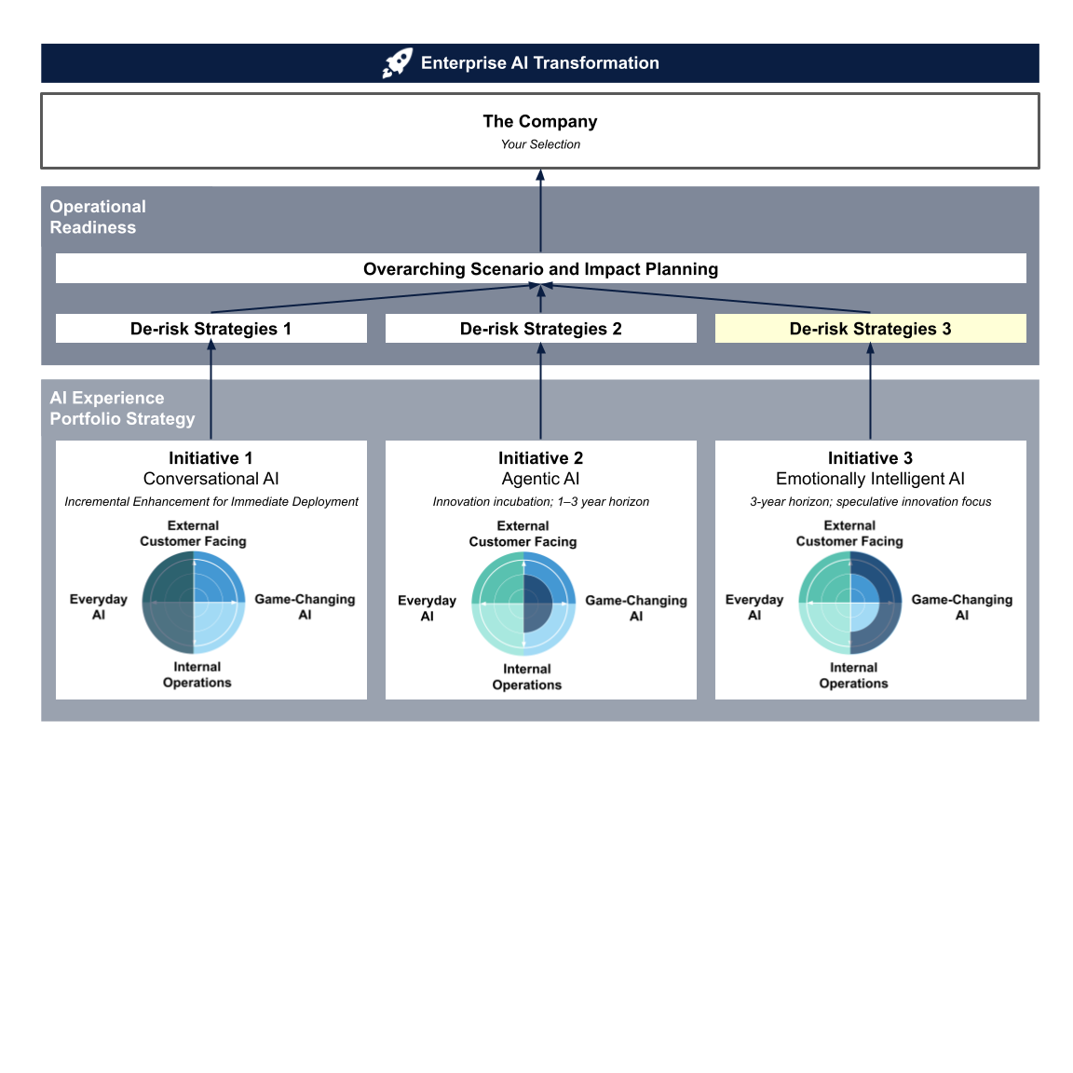

A. Risk Profile
After completing the second de-risking strategy for Initiative 2, you’ve gained valuable practice in mitigating risks for a promising yet less-mature AI capability.

Now you’ll move on to de-risking Initiative 3, Emotionally Intelligent AI. The exercises remain largely the same, with one caveat: most live-production methods (pilot programs, A/B testing, continuous monitoring) are not applicable in the EU until legal approval or relocation, so method selection will be more limited. Your analysis must also address additional unknowns related to market readiness for this capability.

Reference:
- Module 5 Designing for Trust: Human Side | AI Side | Principles
- Module 9 Early AI Idea Fit: Lean Experiments: Jobs-to-Be-Done | Assumption Dump | Lean Experiments in Action

Step 1 Assumption Dump
Experience Goal: | Guiding Prompts:  - What is your Emotion-AI experience ultimately trying to achieve for users?  - What user benefits emerge when the system recognizes feelings compared with a “neutral” AI (e.g. reduced effort, stronger sense of being understood, higher loyalty)?  - Which downstream business functions (support, marketing, retention) stand to gain and what KPI shift do you expect?  Sample Case: Provide an always-available companion that gauges an elder’s emotional state and daily context, delivering empathetic dialogue, helpful reminders, and timely alerts, aiming to enhance safety, reduce loneliness, and support independent living. | Your Conversational AI Initiative:

Risk-Category Assumptions Capture:  User Need Fit | Guiding Prompts:  - What core “job” are older adults hiring the companion to do? (e.g. Keep me company when family isn’t around; Remind me about my pills in a caring way; Notice when I sound anxious and calm me down.)  - How do elders currently meet those needs, and where does that process break down?  - In which situations might older adults skip or abandon the companion, and why?  - Which emotional contexts (e.g. evening loneliness, medication confusion, post-fall anxiety) are most critical for the companion to address first?  Sample Assumptions for the Emotion-Aware Elder-Care Companion Case:  - Older adults will share emotions with a voice/video companion if it clearly explains privacy safeguards.  - Feeling “heard” by the companion will lower self-reported loneliness scores.  - Loneliness among older adults is a major reason they may be unable to live independently.  - Empathetic, step-by-step reminders will improve medication adherence compared with standard alarms, thereby reducing accident rates among older adults living independently. | Your Assumptions:

Risk-Category Assumptions Capture:  Business Value | Guiding Prompts:  - Which single hard business outcome are stakeholders “hiring” this companion to improve? (e.g. fewer emergency calls, lower nurse workload, higher subscription retention)  - Where do you expect cost offsets? (e.g. fewer human check-ins, reduced support calls, lower readmission penalties.)  Sample Assumptions for the Travel-Booking Multi-Agent Case:  - Emotion-adaptive reminders reduce missed-dose incidents, thereby lowering hospitalization risk and decreasing emergency-department workload for hospitals.  - Camera-off users still achieve 80 % of the engagement of camera-on users through voice and interaction telemetry, so privacy-sensitive households won’t undermine the adoption forecast.  - This solution will keep the false-alarm rate below 2 %, avoiding alert fatigue and potential liability, and it will not increase manual follow-up costs. | Your Assumptions:

Risk-Category Assumptions Capture:  Capability Fit | Guiding Prompts:  - Will common in-home devices (smart speaker, tablet, low-bandwidth Wi-Fi) support real-time audio/video analysis without stalling or overheating?  - If the camera is off or lighting is poor, can voice-only or interaction telemetry still infer mood with acceptable accuracy, or must the companion gracefully degrade to a neutral script?  Sample Assumptions for the Travel-Booking Multi-Agent Case:  - Elders’ home Wi-Fi can support the required end-to-end response times, keeping conversations natural and avoiding the lag that leads to user abandonment.  - The emotion-detection model can maintain high precision and recall regardless of the equipment (speakers, microphones) in elders’ homes, underpinning safe escalation without generating false alarms. | Your Assumptions:

Other Assumptions | If you identify additional assumptions beyond the risk categories while working through the exercise, capture them as well! | Your Assumptions:

Step 2 Risk Profile Assessment
Now, map the assumptions you identified in Step 1 onto the 2×2 matrix below. This priority matrix compares the degree of uncertainty against the potential impact on success, helping you pinpoint which assumptions pose the greatest risk.
- Y-axis: If the assumption proves wrong, how likely is it to kill the idea or product?
- X-axis: How much evidence do you have to back up the assumption?

For the X-axis—evidence—in this simulation, you won’t have access to the company’s internal data, so rely on publicly available information and make an educated guess.

Note: Different innovation horizons carry different levels of risk. Those that lie farther out introduce the most unknowns, so you may be relying on assumptions such as “The market climate will remain unchanged over the next three years.”

After mapping your assumptions, review the chart: how many fall in the top-right quadrant—those with little evidence that, if proven wrong, would likely kill your idea or product? The more assumptions that fall into that area, the higher the risk profile for this initiative.



B. De-Risking Method Selection
Based on your risk profile, you’re now at the method-selection stage. Because pilot programs, A/B testing, and continuous monitoring all require live production environments, they are not yet permitted in the EU without legal approval or relocation. Therefore, for Initiative 3: Emotionally Intelligent AI, you will use only lean experiments.

C. Validation Focus
Reference:
- Module 5 Designing for Trust: Human Side | AI Side | Principles
- Module 9 Early AI Idea Fit: Lean Experiments: Jobs-to-Be-Done | Assumption Dump | Wizard of Oz | Lean Experiments in Action

Method: Lean Experiments


- Desirability: Do people need/want this AI?
Your analysis:

- Viability: Does it make business sense?
Your analysis:

- Capability fit: Could a simpler, non-AI solution work just as well, or does AI provide unique value that justifies its complexity?
Your analysis:

2. Augmenting Organizational Readiness

Introduction
In large organizations, AI’s promise is unlocked only when the entire enterprise is ready, not just when isolated initiatives are launched. Leading companies align skills, processes, and governance before scaling any new AI experience.

In this simulation section, you’ll zoom out to view your three AI initiatives as a unified portfolio and work through exercises that reveal shared readiness gaps and craft cross-cutting enablement strategies.

Purpose
These readiness drills translate classic change management theory into concrete actions for your chosen company. They adapt that theory to the AI specific nuances covered in this module, helping you identify capability gaps early and craft rollout plans that smooth adoption and accelerate value realization.

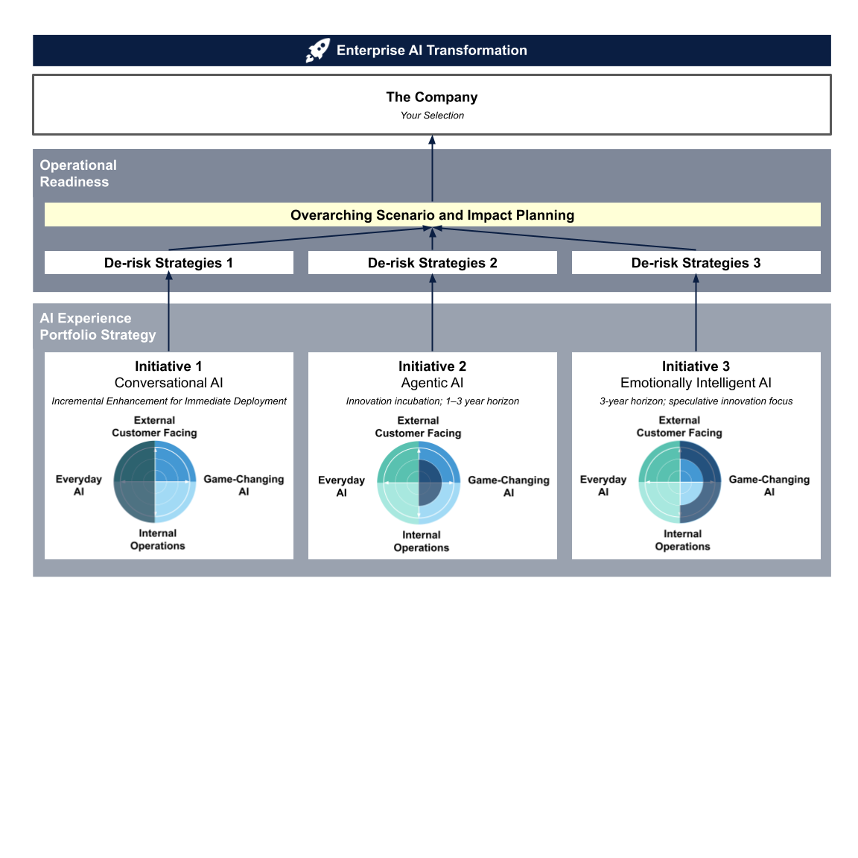

A. Readiness Matrix
First, let’s rapidly surface common readiness needs across all three AI UX experiences you proposed.

Reference:
- Module 2 Trade-off: AI vs. Comfort Zone
- Module 5 Designing for Trust: Human Side | AI Side | Principles
- Module 10 Preparing for AI’s Impact on: Productivity | Cognition | Learning

Leverage the user insights you gathered for each AI initiative to identify the internal functions, such as sales reps, support teams, analysts, managers, and designers, that support the experience. Then identify the external customers that experience is designed to serve.
In each cell, list the skills, processes, decision aids, or tools those stakeholders need to perform effectively at AI speed.

Experience \ Lever | Productivity | Cognition | Learning
Conversational AI
Agentic AI
Emotionally Intelligent AI

B. Capability Clusters
Take what you noted down from Exercise A (readiness matrix) and group similar or shared skills, processes, decision aids, and tools across the portfolio. Each group of shared skills, processes, decision aids, and tools is a capability cluster. Bucket them into three to five overarching capability blocks. For example, “GenAI literacy” or “peer coaching.” For each block, write two to three bullet points describing the items/actions needed to build that capability.

Capability Block 1: _____________________________

Capability Block 2: _____________________________

Capability Block 3: _____________________________

Capability Block 4: _____________________________

Capability Block 5: _____________________________

C. Impact-Effort Prioritization
Place each Capability Block into the 2×2 grid. Then identify 2–3 Quick Wins for your 30‑day action list. The effort axis refers to the amount of effort a company must invest in order to set up that capability.

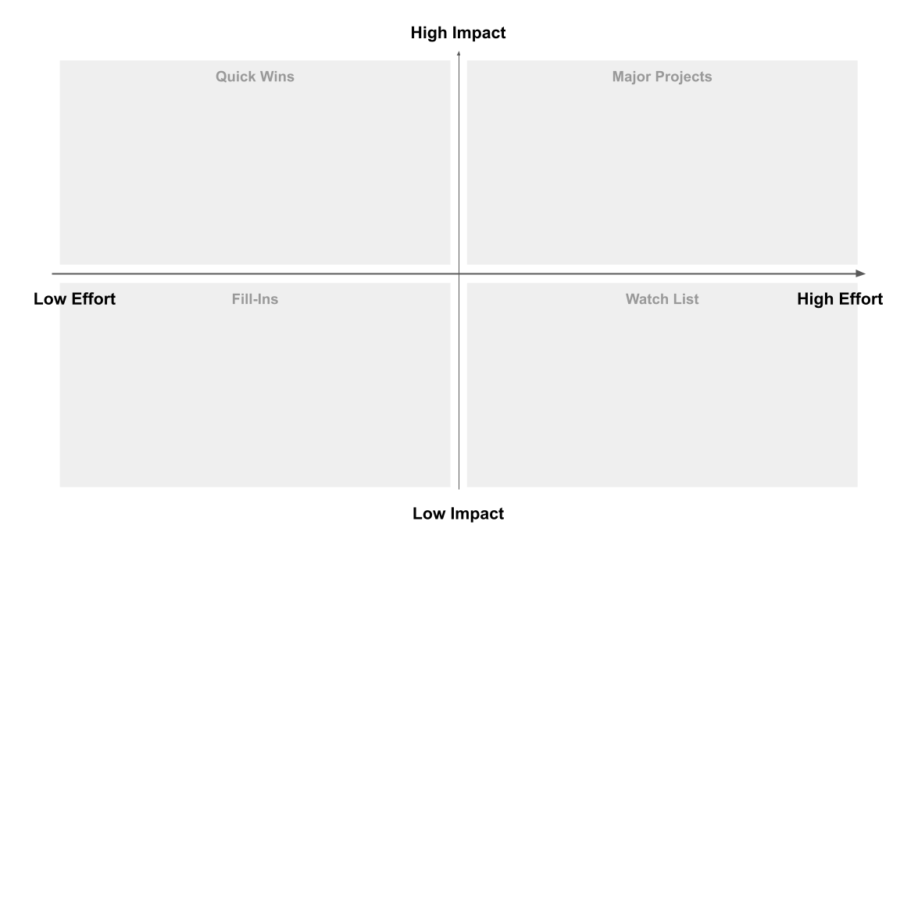

D. Enterprise Readiness Blueprint
Translate prioritized blocks into time‑phased actions with what success looks like.

Zoom-out Check:
- Does this roadmap clearly ladder up to the AI experience portfolio and the targeted vision you proposed?
- Do these actions create shared efficiencies across all three AI experiences?
- Will quick-win deliverables (e.g. data pipelines, prompt libraries) become building blocks for the major projects, avoiding duplicate work?
- Beyond internal teams, do these actions create ecosystem efficiencies—for partners, suppliers, or end users—that compound value?

Action Plan \ Tactics | Capability Block Focus |  | What success looks like
30-Day Action | 2-3 quick wins
90-Day Action | Expand to major projects build
180-Day Action | Scale & additional majors

3. Fortifying the Future Portfolio

Introduction
Innovation now moves too fast, and AI evolves too unpredictably, for companies on the path of AI transformation. Enterprises are therefore turning to Fortifying the Future Portfolio, a foresight practice born of two tiers of uncertainty. Rather than betting on a single forecast, leaders employ scenario planning to map multiple plausible futures and stress-test their AI initiatives in each.

In this simulation, you’ll replicate that process, examining how your three designs hold up, and even strengthen, across radically different worlds.

Purpose
This scenario-planning drill turns abstract volatility into a strategic asset. You’ll practice mapping divergent futures, diagnosing initiative vulnerabilities, and refining no-regret moves that keep AI experiences valuable, even when the future unfolds unexpectedly.


A. Environment Scan
Begin by scanning the external environment for key drivers of change and major uncertainties that could affect your AI initiatives.

External drivers are the broad forces or trends (technological, economic, social, regulatory, etc.) shaping the future. Uncertainties are factors you know are important but whose future outcomes are unpredictable.

By the end of Step 1: You should have a broad list of external factors – both trends and uncertainties – that might shape the future environment for your AI projects. For instance, you might note things like “AI technology breakthroughs,” “public trust in AI,” “global economic stability,” “data privacy laws,” “number of AI-savvy competitors,” etc., along with a sense of why each matters.

Reference:
- Module 11 Topic Overview
- Module 11 Navigating Uncertainty with Strategic Foresight

Step 1 Drivers Inventory
This step is essentially your research and brainstorming phase to understand the context in which your AI projects will operate. Cast a wide net to identify relevant forces. We provide a starting list of crucial forces; as your research deepens, add more. Aim to list as many possible drivers as you can. You’ll narrow them down later.

Political/Regulatory:
Thinking prompts:
- Are there any anticipated policy changes, regulations, or legal issues related to AI that could constrain or accelerate your initiatives? Consider examples such as data privacy laws, AI ethics guidelines, or new compliance requirements. Focus on either your selected company or its industry.

Social/Economic:
Thinking prompts:
- What social dynamics or market trends might impact adoption of AI solutions? Think about consumer attitudes toward AI, workforce skills and acceptance, economic conditions (boom/recession) that affect budgets for AI projects, etc.

Technological:
Thinking prompts:
- What emerging AI-related technologies (e.g. quantum computing), or which AI-forecasting metrics based on our early learnings, could most dramatically influence your AI initiatives?

Environmental:
Thinking prompts:
- What environmental or sustainability trends, such as the soaring energy demands of AI data centers or water-and-resource scarcity pressures, could reshape your industry and impact the viability or design of your AI initiatives?

Competitive and Industry Forces:
Thinking prompts:
- What are competitors or industry leaders doing with AI? Could a new competitor or alternative technology disrupt your plans (e.g. a breakthrough making your solution obsolete)?

Others: _____________________________

Others: _____________________________

Step 2 Uncertainties vs. Certainties
Among the factors you listed, which are highly uncertain in how they will play out (e.g. “Will government regulate AI heavily or not?”) versus those that are more predictable trends (“Continuous increase in computing power”)? Mark the truly unpredictable but potentially impactful ones. These are your critical uncertainties to focus on in the next steps.

Uncertainties |  | Certainties

B. Uncertainty Pairing
From your list of factors, identify the two uncertainties that are most critical to your scenario planning. These should be the two factors that both (a) have a large potential impact on your AI initiative’s success, and (b) are highly uncertain (plausible outcomes at either end of the spectrum).

The idea is to choose the two drivers that will form the axes of your scenario matrix, because their different possible outcomes will define very different worlds. It’s important that these two uncertainties are largely independent of each other (so that each combination of outcomes yields a distinct scenario, rather than one simply overshadowing the other).

Reference:
- Module 11 Topic Overview
- Module 11 Navigating Uncertainty with Strategic Foresight

Work through the following three narrowing-down prompts to help you select your uncertainty pair.

(a.) Large potential impact
Thinking prompt:
- Good Example: When a shift in data privacy law could completely block your user-data-driven recommendation engine (e.g. GDPR-style restrictions shutting down your core data pipelines), this means a large potential impact.
- Bad Example: A trivial change like a data-attribute format tweak (e.g. renaming a field in your JSON payload) rarely makes or breaks an AI initiative, so it wouldn’t qualify as a high-impact uncertainty.

(b.) High Level of Uncertainty
Thinking prompt:
- Good Example: Public trust in AI could swing from widespread enthusiasm (driving mass adoption) to deep skepticism (leading to boycotts or bans). Both outcomes are believable.
- Bad Example: Companies can rebrand deliberately and announce the change. However, this change is deliberate and easily known, not an uncertain external force for planning.

(c.) Independence of Uncertainties
Thinking prompt:
- Good Example: “Regulatory strictness” (tight vs. lax rules) paired with “AI compute costs” (high vs. low). These two vary separately: rules don’t directly force hardware prices.
- Bad Example: “Compute costs” and “training dataset size.” These tend to move together; lower hardware cost usually means bigger datasets. Combining their extremes will not produce four truly different worlds.

Your Selected Uncertainties
What’s your final selection:

Uncertainty A: _____________________________
Uncertainty B: _____________________________

C. Future Grid
Now, let’s plot your selected uncertainties on a 2×2 grid to visualize four distinct future worlds.

Reference:
- Module 11 Topic Overview
- Module 11 Navigating Uncertainty with Strategic Foresight

Step 1 Define the Extreme Outcomes for Each Uncertainty
For each of your two critical uncertainties, clearly define the two extreme outcomes that will form the endpoints of that axis.

Imagine each uncertainty as a continuum or spectrum, and articulate what the opposite ends of that spectrum look like. These should be plausible, distinctly different states of the world for that factor.

Defining extremes helps ensure your scenarios are well-differentiated. One end might be very favorable to your objectives and the other very challenging. Remember: extremes should be realistic enough that you could envision the world that way (even if it’s uncomfortable).

Thinking Prompts:
- For Uncertainty A, describe its two extremes:
  - Extreme A1: What is one end of the spectrum? (e.g. “Government imposes strict, sweeping AI regulations”).
  - Extreme A2: What is the opposite end? (e.g. “Minimal AI regulation – a free-market approach”).
- For Uncertainty B, describe its two extremes:
  - Extreme B1: One end state (e.g. “Public fully trusts AI – high adoption and comfort”).
  - Extreme B2: Opposite state (e.g. “Public distrusts or fears AI – widespread reluctance or backlash”).

Visual workspace:

Uncertainty A:


Uncertainty B:


Step 2 Draw the 2x2 future grid Matrix
Now, map your previous step’s results into the future grid matrix. This 2×2 grid lets you visualize four distinct scenarios, each arising from one combination of the extremes you defined.

Note: This scenario-planning 2×2 differs from the assumption-prioritization 2×2 used in the Lean experiment. In the Lean grid, one quadrant highlights your primary focus; in the future-grid 2×2, each quadrant is equally important, each represents a unique potential world.

D. Scenario Narratives
Now comes the creative and analytical part: writing your scenario narratives. Creative in that you’ll use your imagination to envision possibilities and answer, “What would the future look like under this combination of conditions (e.g., extremes A2 and B2)?” Analytical in that you’ll ground your speculation in the real-world research you conducted in Step A: Environmental Scan. This isn’t sci-fi, but informed forecasting.

For each of the four quadrants in your matrix, develop a plausible narrative describing that world and how your organization’s AI initiatives fare. Focus on the external environment and its impact on your business—not on guaranteeing success—and explore the challenges and opportunities each future presents. Keep each narrative coherent, specific, and believable, with its own internal logic and outcomes.

Aim for a few paragraphs per scenario, covering key aspects of how the world functions. Then, give each scenario a memorable title that captures its essence, making it easier to reference in discussion.

Scenario 1 (Extreme A2 and B2)
Title: _____________________________

Scenario 2 (Extreme A1 and B2)
Title: _____________________________

Scenario 3 (Extreme A1 and B1)
Title: _____________________________

Scenario 4 (Extreme A2 and B1)
Title: _____________________________

E. Initiative Stress-Test
With the scenarios in mind, analyze how each scenario affects your AI initiatives and your organization’s plans and strategy. Note whether each initiative thrives, struggles, or requires adaptation.

 | Scenario 1 | Scenario 2 | Scenario 3 | Scenario 4
Conversational AI
Multi-agent AI
Emotionally Intelligent AI

F. Resilience Playbook
Finally, use insights from your scenarios to evaluate your strategic options. Identify no‑regret moves (actions that succeed in all futures) and scenario‑specific contingencies (actions to take only if certain conditions materialize).

Thinking prompt:
- What strategies would be most effective in each scenario, and what indicators will prompt you to adjust course?

The outcome will be an informed strategic plan that is robust (resilient to different futures) yet adaptive (with specific responses ready for specific conditions).

Synthesis:

© This publication offers guidance, not legal, compliance, or security advice. Adapt recommendations to your sector, risk profile, and regulatory requirements.

